**Technical Support for the Preparation of Flood Risk Management Plans for Romania**

**RO FLOODS RAS (ID: P170989)**

**Roma Pilot for Community Engagement & Social Risk Management in Flood Risk Planning & Response**

Phase 2: Stakeholder Engagement Roundtables

Minute: Bărbulești

Date: 4 November 2022

Location: Bărbulești commune, local church

**Participants:**

* **World Bank**: Oana Ivan, Catalin Berescu, Cosmin Feodorov
* **Water Management Authorities**: Mariana Lăcătuș, Marcela Gheorghe, Roxana Adam (RBA - Buzău Ialomița), Cristian Gănescu (SGA Ialomita)
* **Buzău Prefecture (county level)**: sub-prefect, emergency situations responsible, minority issues responsible
* **County Emergency Situations Inspectorate (ISU):** management representative
* **Buzău County Council**: architect-in-chief
* **Bărbulești commune / local representants**: Vasile Liță Mayor, Zobar-Marian Cuțitaru Vice-Mayor, Virgil Enache - personal counselor of the mayor, three local counselors, social assistance representative, Church representatives, citizens (more than 25, including 8 women, of all ages)

# Background

**Selection of Bărbulești.** Bărbulești was selected as one of the three Roma communities to participate in the RO FLOODS Roma Pilot as it met the following criteria established for the Pilot:

(i) *Significant share of Roma population within the community*: around 95% of Bărbulești inhabitants are Roma.

(ii) *Communities located within areas with high and medium probability of flooding.*

(iii) *Aiming to cover cases that are representative for their geographical and cultural context and that reflect the socio-cultural diversity of the Roma*: Roma from Bărbulești identify themselves as Ursari, a traditional community where most of the social-cultural norms are still well kept.

(iv) *Covering three types of leadership: (1) strong Roma leadership, (2) moderate level of cohesion through multiple community leaders, and (3) weak to no leadership*: Bărbulești Roma community has a very strong leader, who at the same time is also the mayor of Bărbulești commune. In this case, the Roma leader and the local authority is one and the same person. In addition, the local council is 100% Roma.

# Flood Risk

The key issue stands with the particular position of Bărbulești at the confluence of two rivers, and in the dynamic of the flood waves on Ialomița and Prahova, that is regulated by the Dridu reservoir.

The last major event occurred in September 2005 and led to the destruction of at least 200 houses, to the displacement of around 2000 people and to three fatalities. Water retreated very slow, in a matter of 3 weeks and the recovery process was long. The need for higher and reinforced dikes is strongly highlighted by the local administration and well acknowledged by River Basin Administration (RBA) who has plans for hydro-technical works in the future.

The area that was destroyed is now entirely rebuilt and inhabited by a large number of persons, while the dikes were only repaired and are not yet consolidated in order to secure a proper level of protection in case of major flood events (the dike requires to be heightened). It is likely that a similar event will have a major impact on the central area of the village. Despite the better quality of the houses that replaced the old mudbrick houses of the past, there is still a significant flood risk since, like in most villages of Romania, the buildings don’t include flood protection specifications in the design, and they’re not adapted to the local conditions. Indeed, the foundations are now raised a bit above the ground level, yet this is not enough, and not present in all constructions.

# Phase 1: Community visit, initial stakeholder mapping and engagement with stakeholders

During the first phase of the Pilot, field visits were carried out during June 2022 in Bărbulești to consult with local stakeholders. During this visit, the Mayor, Vice-mayor and the local councilors were informed about the pilot and despite the lack of confidence in the success of the Pilots and the improvement of the collaboration, giving the exclusion they perceive in relation to the regional authorities, they confirmed their support and willingness to participate.

After visiting the community, the WB team participated at meetings with Ialomița County Council, Emergency Response Inspectorate (ISU) Ialomița, Ialomița Prefecture, including the regional and local level water management authorities: the RBA and Water Management Unit (SGA). Despite some level of skepticism existed in some cases, all representatives showed interest and support for the Roma Pilots, for further meetings and activities proposed.

# Phase 2: Stakeholder roundtable

## Objective

Promoting a dialogue among the key stakeholders around flood risk issues, factors raising risks, actions that could reduce risk and effectively respond to emergencies, together with the community.

## Key issues discussed

After a presentation was made by the World Bank team and RBA on the objectives of the RO FLOODS Project and to present the Roma Pilot (findings of Phase 1, Pilot Phases, etc.), the floor was opened for stakeholder dialogue. The following issues were discussed:

1. **Flood protection**: The need for dike reinforcement was acknowledged by both the local authority and the water management authorities. The RBA communicated about an existing project for this hydro-technical works and their current stage, as well as the lack of financing, which represents the biggest issue. The identification of necessary funds needs support from central government authorities, hence all parties involved agreed to take action for increasing awareness about the existing technical project and the pressing need to implement it.

The discussion also addressed the works done by the municipality for a promenade built on the Eastern side of the dike, that was executed without the approval of the water management authorities and can endanger the structure of the dike. The need to have legal and technically compliant works on the flood protection infrastructure was explained by the RBA.

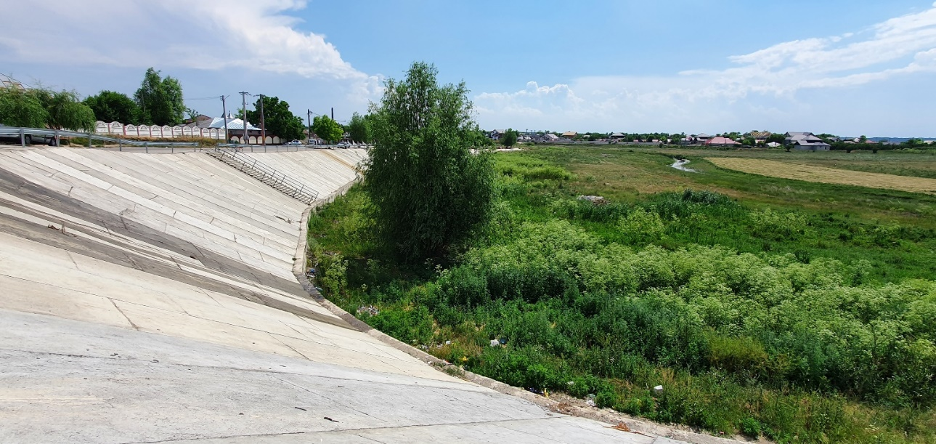

1. **The local request to build a small football stadium** for the community and the challenges to obtain the necessary permits from the water authorities as the proposed location is situated in a flood risk area. The objective to have a sport facility in the commune is also related to their difficult access to the football pitch of the city of Urziceni (the closest location available), due to racist attitudes.

A mitigation strategy was proposed and the problem of building considering the special safety conditions was understood by the local authorities and they will consider revising the proposed project according to the legal requirements.

1. **Urban Planning**: The issue of households built in the flood risk area was also addressed: since the commune as it is now established in 2006, urban planning was limited to issuing building permits, and not considering all the legal requirements for a flood prone area. The community is well established, and the houses are already built, hence the informality aspect is not an issue in this community. The mayor and the community acknowledge the risks of the current housing situation, but they also accuse the lack of available land in the commune for the new families and constructions. The county chief architect placed this situation in the general context of planning at the county level, highlighting that the issues faced by the Roma community are present in other locations as well. Among other aspects, the lack of drinking water is an issue faced by the community.
2. **Emergency response**: the SGA representative lead the discussion and recapitulated the requirements needed at local level for preparedness and response to floods. It was reconfirmed that the municipality has a formal responsible nominated and there is a good collaboration with the SGA, and the preparedness and response measures are in place.

It is not clear if there is a formal group of volunteers organized for emergency situations, beside the local community with the extended family which respond in case of an emergency. The high migration mobility in the community creates a significant fluctuation of the people that might be affected and engaged in case of a flood. ISU mentioned that they are providing specific trainings and drills in the county and acknowledged the need to extend preparatory trainings at local level to selected members of the community to provide additional support in case of flood emergency.

1. **Waste management**: unlike in other locations, waste management is not a major issue, the waterways are cleared, and the local authority is managing the waste efficiently.

## Next Steps / Follow-up

* RBA and SGA together with the local authority to establish a working calendar to further discuss the topics approached at the round table: the football field, the reinforcement of the dyke, the houses build inside the flooded area.
* ISU together with the local authority to organize a training / drill for floods events with the community members.
* The World Bank team to communicate about the round table results and findings of the Roma Pilots to increase awareness on the needs of the Roma communities and stakeholders involved.
* **Phase 3 of the Roma Pilot**: Meeting participants agreed to continue their support for Phase 3 of the Pilot – Roadmap for community engagement and dissemination:
  + (i) Present the results of the Pilot to the Roma community, to their leaders and stakeholders involved and take note of the feedback received.
  + (ii) Present the results of the Pilot to the National Administration Romanian Waters (ANAR) and to the 11 RBAs under their coordination as an example of good practice and tool for community engagement.
  + (iii) Provide a training to all RBAs on the roadmap developed under the Roma Pilot.

# Conclusions and general comments

The meeting was very well organized and productive, with great support from the mayor’s office, local church and community members. The welcoming atmosphere was appreciated, and all participants expressed their opinion and interest for further collaboration.

The fact that the mayor of Bărbulești and the Roma leader of the community is one and the same person, with resources and support of the community is very important for preparedness and emergency response in case of flood. The solidarity that exists in the community, the support of the church and the religious extended family (Pentecostal) also play an important part in case of emergency. **This are strong assets of this community, and the water management authorities and ISU, and any other public administration, should acknowledge and use to further build resilience and cooperation.**

The level of trust and confidence between the community and local, county and regional authorities is low, yet the in-person communication provided by **the roundtable discussions clearly enhanced the understanding of concerns and limitations faced by different sides and evolved from expressing the issues faced by each, to discussing ways of collaboration to find solutions.**

It is important to note that everybody allowed all the others to express their opinion and engaged in a polite and clear communication and the fact that **the results mentioned above, and the agreements reached were achieved in only one roundtable meeting.** Some of the issues discussed at the round table require long term solutions and it’s critical that all parties continue to work together. There are many strong points to build on and the discussion on legal issues showed a strong commitment to legality of the municipality. The improvements to communication and collaboration between all parties need to continue, as Roma leaders feel marginalized and excluded, due to discriminatory attitudes.

All parties agreed that the roundtable meeting and the World Bank RO FLOODS Roma Pilot are valuable to advance dialogue on critical issues for flood risk management and expressed their support to continue. **The participants acknowledged the value of the work to be followed up and even reproduced in other locations, with other Roma communities and the local authorities.**

Participants expressed thanks to the World Bank and RBA for the support and facilitation to bring stakeholders together, enhancing information flows, and promote dialogue and collaboration.

**The example of this meeting shows that here is a strong premise that better collaboration for floods management can serve other sectors as well, as best practice and example of Roma communities working with public authorities.**

# Pictures from the site

Flood in 2005 destroyed more than 200 households

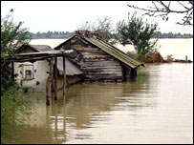

Round table with stakeholders at Bărbulești local church

Local strategies for flood protection: building houses on a higher base and with better materials, but not enough in the eventuality of a severe flood

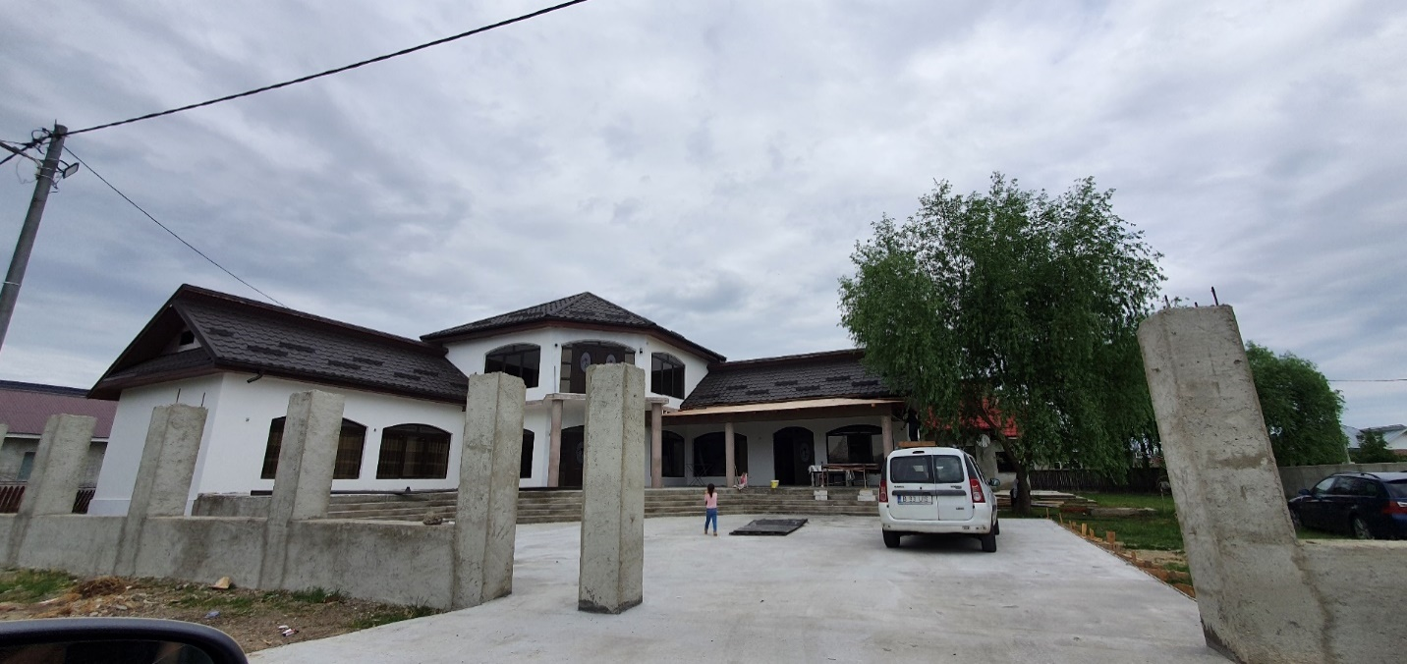

New house built in the flooded area, replacing the old house, swept away in 2005

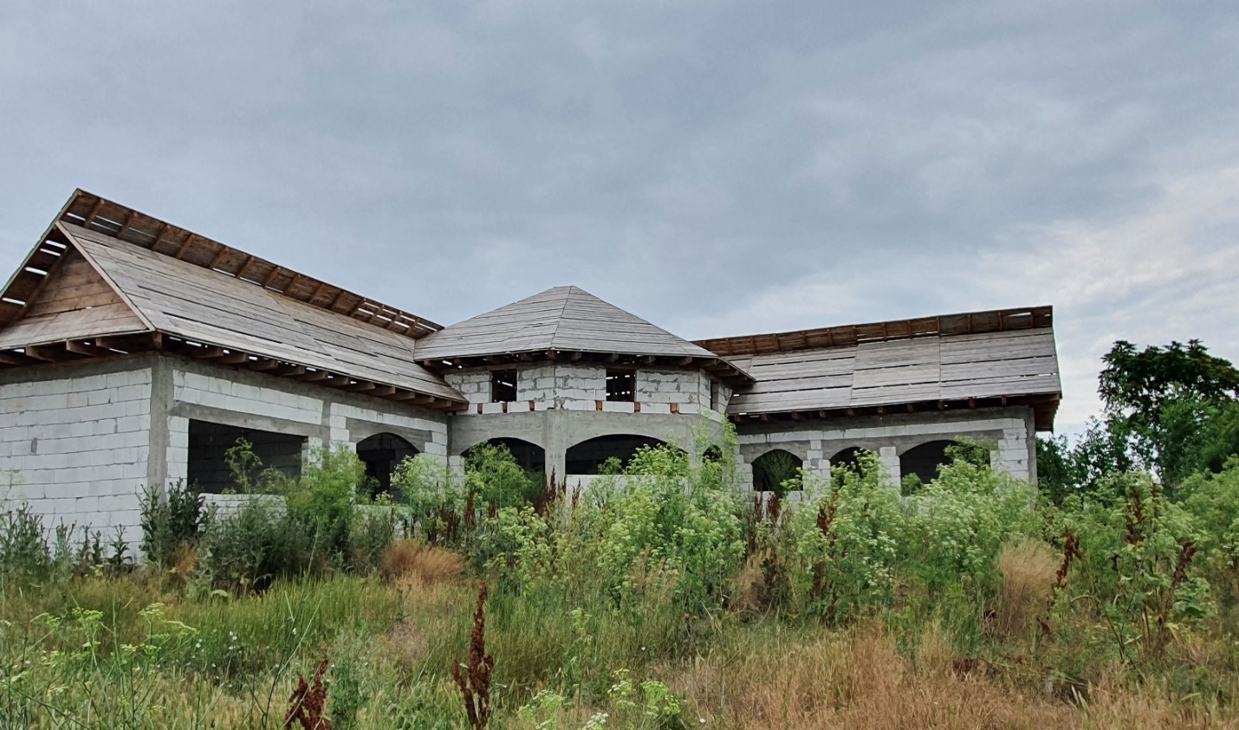

Houses built after the 2005 flood with governmental funds. However, religious and family solidarity played the most important role in the village reconstruction

