**Technical Support for the Preparation of Flood Risk Management Plans for Romania**

**RO FLOODS RAS (ID: P170989)**

**Roma Pilot for Community Engagement & Social Risk Management in Flood Risk Planning & Response**

Phase 2: Stakeholder Engagement Roundtables

Minute: Roșia Montană

**Date:** 7 November 2022

**Place:** Roșia Montană commune, city hall

**1.0 Participants:**

* **World Bank:** Dianna Pizarro (Sr. Social Development Specialist, WB); Oana Ivan, Catalin Berescu, and Ioana Dobrescu (Consultants on Stakeholder Engagement and Roma Inclusion, WB).
* **Water Management Authorities:** Monica Gheorghe (RBA Mureș coordinator – emergency situations responsible), Razvan Obreja (RBA Mures) Ioana Săliștean (SGA Alba chief engineer), Cosmin Ciungan (SH Turda)
* **Roșia Montană commune**: Eugen Furdui, Mayor; Vasile Morariu Vice-Mayor; Valvarea Cristian (chief of Roșia Montană police department)
* **Roma Community Representatives:** Valentin Nuță (local counselor); Doru Nuță; Horia Nuță; Viorel Bratima; and four other Roma citizens
* **Alba Prefecture (county level):** Octavian Ciurea (specialist for minority issues)
* **Alba County Council:** Sorin Vladimir (urban planning department)
* **County Emergency Situations Inspectorate (ISU):** Mr. Valvarea (ISU representative)

**2.0. Background:**

2.1 **Selection to participation in Pilot.** Roșia Montană and the neighborhood where the Roma community lives, Dăroaia, was selected as one of the three Roma communities to participate in the RO FLOODS Roma Pilot as it met the following criteria established for the Pilot:

1. *A* s*ignificant share of Roma population within the community*: around 70% of inhabitants in Dăroaia are Roma;
2. *Located within areas with high and medium probability of flooding* *(mapped as APSFR T10 and T100).*
3. R*epresentative for their geographical and cultural context while reflecting the socio-cultural diversity of the Roma*: Roma from Roșia Montană identify themselves as Roma who have kept the Romani language but have lost other aspects of their cultural identity.
4. *Representative of diverse types of Roma self-governance and leadership (as requested by the RBAs): (1) strong Roma leadership, (2) moderate level of cohesion through multiple community leaders*, and *(3) weak to no leadership*: Roșia Montană has multiple leaders, representing different factions and a strong sense of autonomy in voice.

2.2 **Hazard Risk Profile.** Dăroaia, the Roma community in Roșia Montană, faces two major hazard risks, including floods and landslides. Flood risk threatens the houses built directly upon the riverbank, just a few meters away from the Abrudel river. The Abrudel river’s tributaries are collecting the mountain streams that during storms are prone to flash floods. At the same time, with heavy storms, landslides threaten the houses built at the base of the hill, across from those build along the riverbank. The phenomena of landslides is newer, with the first major landslide being reported by the community in 2021.

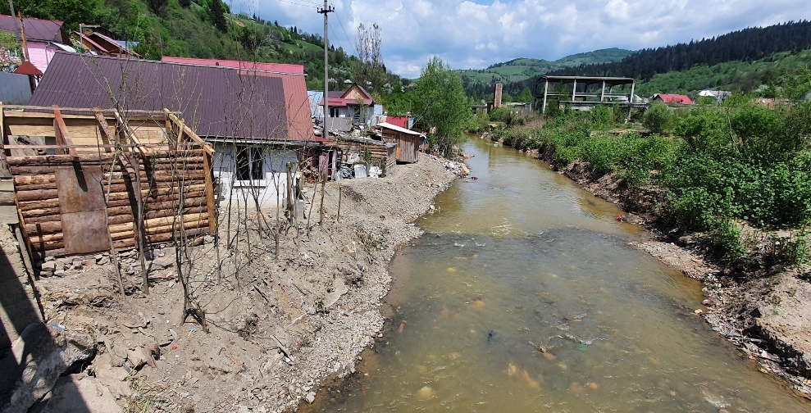

According to the Roma affected community members, the minor mudslides that they had been accustomed to, escalated into serious landslides in 2021. The community claims that the cause of the landslide was a forest cooperative’s recent deforestation of the hill above their community.

In the 2021 major flood event, the entire community was caught between the waters rising from the river and the land sliding from the hill. Dăroaia’s only access/evacuation routes are two bridges on each extreme side of the community, and both were affected by floods during the event. The locals feared the bridges would be carried away by the flood, before they would be able to cross them.

The severity of the landslide combined with the flood event swept away homes and significantly affected the houses and the community safety. After the event, the responsible authorities (ISU, Prefecture, Mayor’s office) evaluated the conditions in Dăroaia and informed the community that they would need to leave the area or if they wish to return to their homes, which were not safe, they would do that on their own risk. In this sense Since most families refused to leave or returned after the emergency evacuation, they were asked to sign a document in which they acknowledge the risks they face in the case of a future hazardous event and they would be solely responsible for possible damage. The people who signed the document are categorized as “self-evicted”. There were no permanent solutions for relocation (land and housing) offered to affected community members.

2.3 **Roma Pilot, Phase I.** The Roma Pilot supports community and stakeholder engagement around flood risk management planning through three phases. A Roadmap for Engagement of Roma Communities will be prepared based on lessons from the Pilot in the three communities. Phase 1 included community visits and an initial identification and engagement with stakeholders. During the first phase of the Pilot, field visits were carried out during May 2022 in Roșia Montană to consult with local stakeholders. During this visit, the Mayor, Vice-Mayor and ISU representatives were informed of the objectives and process of the RO FLOODS Roma Pilot and confirmed their support for implementation and willingness to participate in the next Phases. The Roma community leaders showed interest to participate in future meetings, and during the initial site visits, proposed an agenda and key issues to be addressed. These leaders proved to be very well informed, very knowledgeable of the existing issues and provided clear messages.

After visiting the community, the World Bank team participated at Alba Iulia and Turda in meetings with Alba County Council (including the county chief architect), ISU Alba, Alba Prefecture (including emergency situations representative), including the regional and local level water management authorities: Mureș River Basin Administration (RBA) and Turda Water Management Unit (SGA). Despite some level of skepticism existed in some cases, all representatives showed interest and support for the Roma Pilots, for further meetings and activities proposed.

In preparation for Phase II, after the initial field visits, the WB team met bilaterally with all stakeholders to agree on a time, place and agenda for the Phase II Stakeholder Roundtable.

**3.0 Phase II Stakeholder Roundtable**

3.1 **Objective.** Promote a dialogue among key stakeholders in pilot Roma communities around flood risk issues, factors raising risks, and actions that could be adopted by all parties to reduce risk and effectively respond to emergencies.

## 3.2 **Key issues discussed.** The World Bank team and RBA presented the objectives of the RO FLOODS Project and the Roma Pilot (methodology, findings of Phase 1, objectives, next steps). After this presentation, which provided context for discussion, the floor was opened for stakeholder dialogue and facilitated by the WB. The following issues were discussed:

1. **Urban planning:** All parties agreed that dignified land and housing solutions in an alternative location are necessary for at least some households within the community, as for many homes no mitigation option could adequately reduce their risk. Whereas the Roma community leaders explained that internal preferences on relocation are mixed, they wanted to know whether local authorities could offer alternatives. Local authorities explained that although land had been identified, advancing on securing alternative land and housing options for community members was not possible until a new urban plan (“plan urbanistic general - PUG”) could be approved. The Local Authorities explained that until a resolution was reached by the World Bank’s ICSID tribunal around the pending mining case, it was impossible to approve the urban plan. They also noted that the designation of the area under UNESCO protection, further complicates and inhibits their capacity to find alternative land solutions.

1. A group of people standing outside a house

   Description automatically generated with low confidence**Floods mitigation measures:** Community membersnoted that an existing retention wall had been effective in reducing impacts from past floods and requested that the RBA reinforce the wall. The RBA explained that they could not alter the existing wall as it is legal property of the mining company. The Hydrographic System Unit (SH) representative described the maintenance works that were done after flood event in 2021 and this year as prevention. He also highlighted the fact that the landslides are not in the responsibility of the water management authorities. The protection wall on the right bank of the river is not under administration of the water management authorities, but it’s owned by the mining company Minvest Deva, while the wall on the left bank was raised by the former mayor in 2002 to better protect the community after the floods in the year 2000. Roma representatives asked for an extension of the protection wall, but the implementation of the works is affected by property issues.
2. 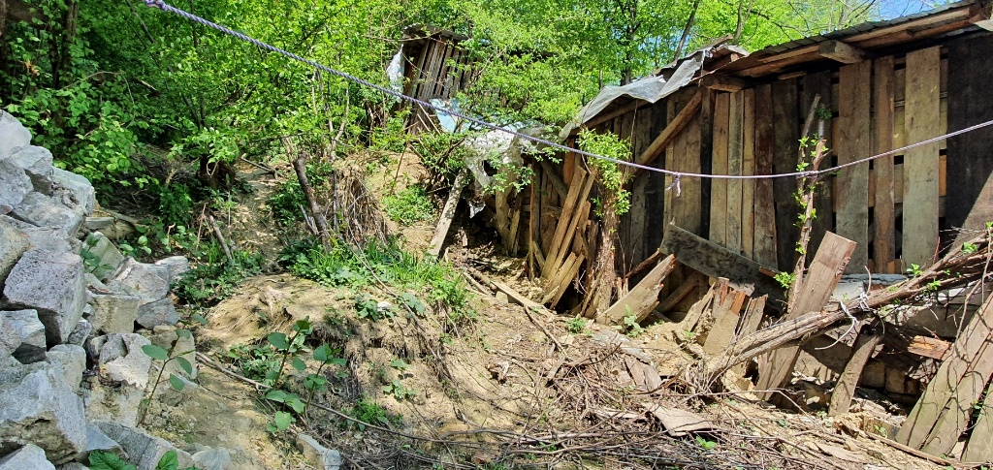**Geological study to determine future risk and cause of landslides:** Community members asked local authorities for updates regarding the geological study that they had committed to make to understand the causes and risks of landslides. Local authorities claimed that the study was published for public procurement, but the process was abandoned due to lack of interest from consulting firms. The causes of the landslide were under dispute as community members blame the 2021 landslide on the forestry cooperative (“composesorat”) that has been deforesting the area from the slopes above the community, for which they have submitted formal complaints with no answer. The local authorities claimed that the landslides were caused by the Roma community’s building practices, where parts of the lower slope are being removed to build homes and destabilizing the hill. The local authorities committed to restart the public procurement and proactively promote the process with potential contractors.
3. **Emergency Response Process:** The community leaders raised several grievances around the management of the past emergency response process, claiming that discriminatory practices and violations of the legal framework both in the conditions for temporary shelter as well as in the ability to return to the community. One leader noted that when non-Roma evacuees requested to return to their homes they were allowed to while Roma community members were not allowed. The ISU members were adamant that discrimination did not occur, and that the safety was the primary criteria applied for all decisions made. They also stated that Dăroaia, was the least affected of the four areas of the 2021 flooding and that it was the place where they had the fastest response. Community members requested training on the existing emergency evacuation protocols as well as on clarity around their rights for temporary shelter when an emergency would take place. ISU noted that they provide those trainings every six months and committed to organizing a training with the Roma leaders for their community.
4. **Waste Management:** Solid waste management was identified by all parties as a critical contributing factor to both flood risk and a lack of dignified living conditions. Local authorities explained that two sets of garbage disposal bins had been placed at the two peripheries, yet community members were not using these. The Vice-Mayor also highlighted a garbage collection campaign that he led last spring in the community and noted not only the lack of community response and participation but the fact that community members took some of the trash collected and threw it back in the riverbed. One community member highlighted how the trash others were throwing in the riverbed was directly affecting them and there seemed to be a strong division in the community around waste management practices. The meeting asked the community leaders to implement activities to promote community awareness and behavioral change from within.

## **3.3 Agreed Next Steps/Follow-up**

* The local authorities committed to republish the procurement process for the geological study on landslide risks and causes and proactively promote the process with potential contractors.
* ISU will organize a training on emergency evacuation protocols and rights around temporary shelter and follow up with the community leaders.
* Community leaders committed to work with community members on solid waste management awareness and practices.
* The World Bank team to communicate about the round table results and findings of Roma Pilots to increase awareness on the needs of the Roma communities and stakeholders involved.
* **Phase 3 of the Roma Pilot**: Meeting participants agreed to continue their support for Phase 3 of the Pilot – Roadmap for community engagement and dissemination:
  + (i) Present the results of the Pilot to the Roma community, to their leaders and stakeholders involved and take note of the feedback received.
  + (ii) Present the results of the Pilot to the National Administration Romanian Waters (ANAR) and to the 11 RBAs under their coordination as an example of good practice and tool for community engagement.
  + (iii) Provide a training to all RBAs on the roadmap developed under the Roma Pilot.

# **3.4 Conclusions and general comments**

The meeting was productive and focused as the Roma community leaders were well informed, organized and articulated their priority issues around flood risk management very clearly.

The level of trust and confidence between the local level and community and the county and regional authorities is low, yet the in-person communication provided by **the roundtable discussions clearly enhanced the understanding of concerns and limitations faced by different sides and evolved from expressing the issues faced by each side to discussing ways of collaboration to find solutions.**

Roma leaders showed interest and support in participating in courses together with ISU on emergency response and waste management. The key issues discussed at the round table require both short and longer term solutions and collaboration that all the parties agreed to continue to work on together towards the future.

All parties agreed that the roundtable meeting and the World Bank RO FLOODS Roma Pilot are valuable to advance dialogue on critical issues for flood risk management and expressed their support to continue. **The participants acknowledged the value of the work to be followed up and even reproduced in other locations, with other Roma communities and the local authorities.**

Participants expressed thanks to the World Bank and RBA for the support and facilitation to bring stakeholders together, enhancing information flows, and promote dialogue and collaboration.

**The example of this meeting shows that here is a strong premise that better collaboration for floods management can serve other sectors as well, as best practice and example of Roma communities working with public authorities.**

# Annex 1: Pictures from the site

**Picture 1: Houses built right at the base of the hill, due to the lack of construction plots**

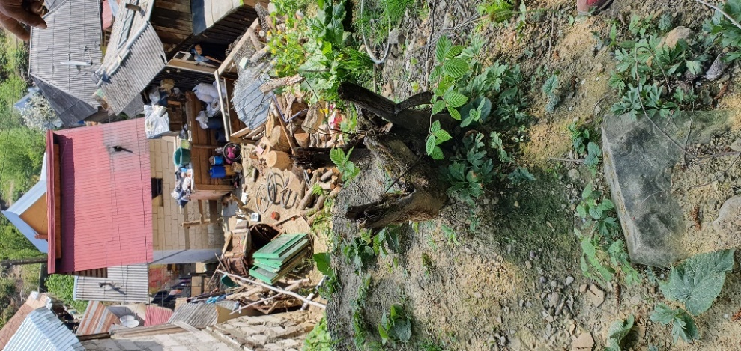

**Picture 2: Improper waste management causing water course blockage**

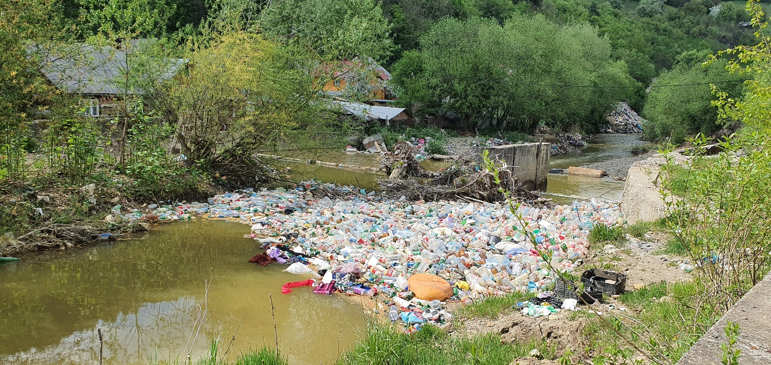

**Picture 3: “Containers” for the self-evicted locals who do not have the means to rebuild their homes**

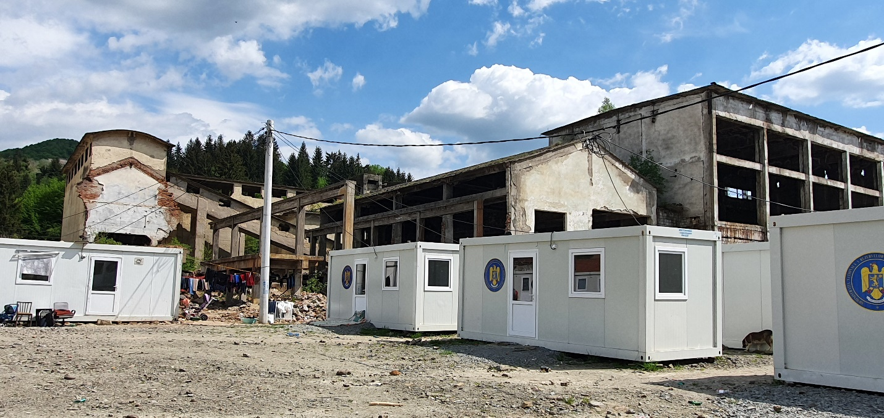

**Picture 4: Protection wall belonging to the mine company that locals would like to see rehabilitated** 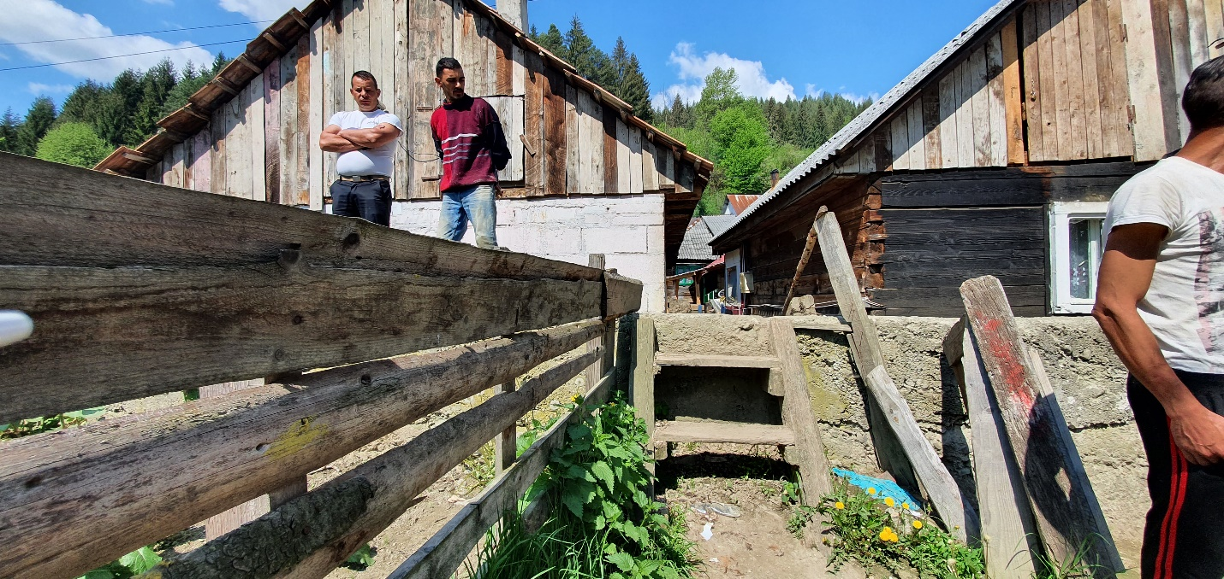

**Picture 5: Round table with stakeholders at Roșia Montană City Hall**

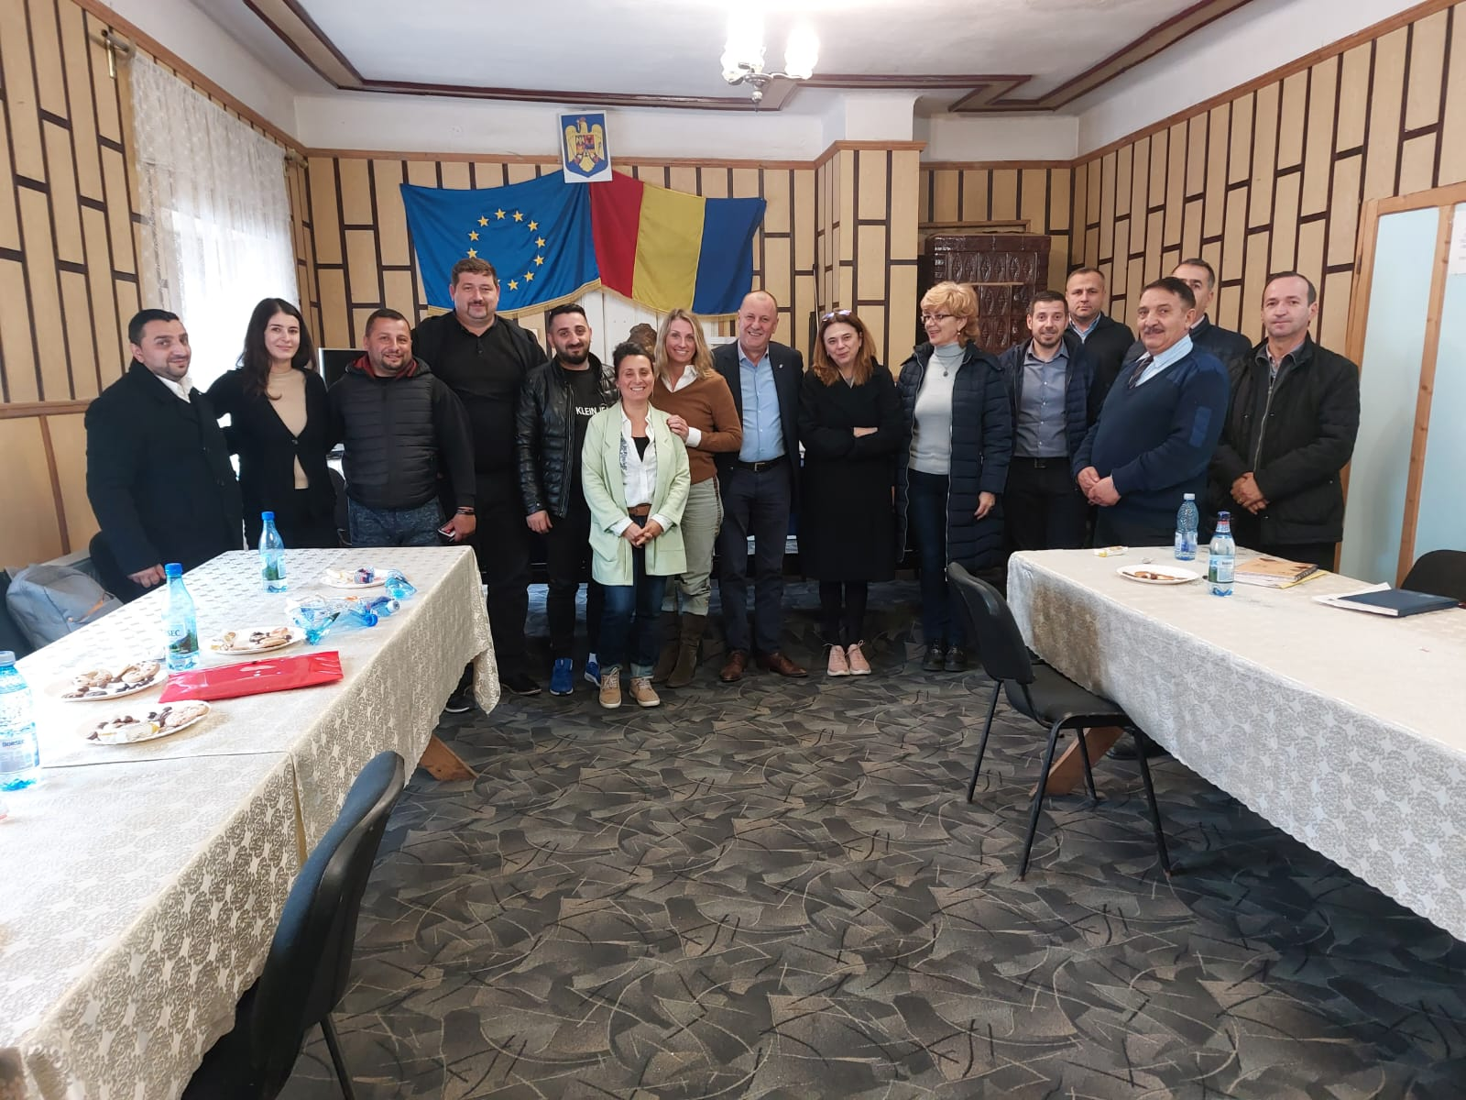

**Picture 6: Emergency shelters placed in the courtyard of the former mining company**

