**Technical Support for the Preparation of Flood Risk Management Plans for Romania**

**RO FLOODS RAS (ID: P170989)**

Roma Pilot for Community Engagement & Social Risk Management in Flood Risk Planning & Response

**Romania is a flood prone country**. Romania belongs to the European countries with the highest risks of floods. The country is ranked fourth in the EU after Poland, the Slovakia and the Czech Republic in terms of floods risks. Climate change is expected to exacerbate the frequency and magnitude of extreme events, hence there is likely to be an increase of flood risk levels in the long term.

The primary institutions involved in water management at the national level in Romania are:

* The **Ministry of Environment, Water and Forests (MEWF)**
* The **National Administration “Romanian Waters” (ANAR),** which also coordinates theNational Institute of Hydrology and Water Management (INHGA)and the 11 River Basin Administrations (RBA).

MEWF holds key responsibilities in the water and environment sector and defines all relevant policies. ANAR manages the waters of the state public domain and the infrastructure of the National System of Water Management.

The **MEWF** and the **World Bank Group** signed on the 16th of October 2019 an agreement for the Reimbursable Advisory Services Project: *“Technical Support for the Preparation of Flood Risk Management Plans for Romania”*. **In short** [**RO FLOODS or INUNDATII.RO**](https://inundatii.ro/en/ro-floods-2/).

**The objective of the RO FLOODS Project** is to enhance the flood risk management capacity of the water management authorities and contribute to a reduction of flood risks in Romania. In this context, the support provided by the World Bank also includes **facilitation of active stakeholder engagement and institutional collaboration** and **fostering flood resilience in marginalized and poor communities.**

The World Bank acts as a facilitator and uses its convening power to bring together different institutional stakeholders and members of civil society, including in marginalized and poor communities. **The inclusion of the Roma minority in flood risk management and the improved consideration of their unique needs and circumstances is an important element for the support provided to the Government of Romania.**

**Roma communities located within areas with significant probability of flooding require a dedicated and often tailored engagement approach for several reasons**: increased vulnerability when a flood occurs, lack of resources for emergency response and recovery, poor access to information and minimal communication with or attention from official authorities, high exposure to natural hazards, low levels of trust between Roma community members and local authorities, unique cultural norms, language and forms of community organization and self-governance, and increased number of vulnerable people (children or elders) within communities.

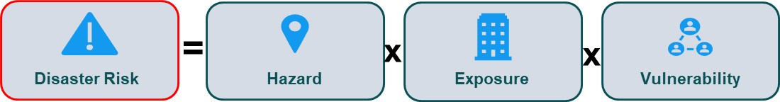

**Objectives of the Roma Pilot**

* *Prepare and deliver an approach for water management authorities to effectively engage marginalized and poor communities for flood risk management.* 
  + Improve dialogue and cooperation among key stakeholders, including the community, local and regional authorities;
  + Design a Roadmap to guide local and regional authorities on key principles and steps to follow to enhance Roma community engagement around flood risk planning and response;
  + Support the joint identification of preparedness, response, and recovery measures that are adapted to the needs of marginalized and vulnerable communities, and also attain community ownership, enhancing probability in the sustainability of results.
* *Showcase a successful Roma community engagement approach for flood risk management.* 
  + Create a Guide for future engagements with Roma or marginalized and poor communities.

In the Pilot the World Bank team, together with the regional water management authorities (RBAs), engaged with three select Roma communities and key stakeholders located in areas with significant flood risk, using a clear structure for preparation and engagement, and documented the approach in order to provide the water management authorities a Roadmap which can be replicated in other Roma and marginalized and poor communities. **The proposed approach can be adapted and used in any other sector (other natural hazards, health or education issues etc.).**

The Pilot proposed **three Roma communities** in different areas of Romania. Selection was made from a long list based on expert knowledge and available data. A set of criteria was used to select the three locations:

1. *Significant share of Roma population within the community.*
2. *Communities located within areas with high and medium probability of flooding.*
3. *Aiming to cover cases that are representative for their geographical and cultural context and that reflect the socio-cultural diversity of the Roma.*
4. *Covering three types of leadership: (1) strong Roma leadership, (2) moderate level of cohesion through multiple community leaders, and (3) weak to no leadership.*

The Pilot is implementing a three-phased approach:

**Phase 1** consisted in the initial preparation for the first community visits, mapping stakeholders and reaching out to the local authorities to present the overall activity, objectives and proposed next steps. The first rounds of visits were made by experienced social specialist consultants with experience in working with Roma communities and a broad network of contacts with Roma leaders and civil society. During Phase 1 these social experts helped identify potential communities to participate in the Pilot, leveraged their contacts with Roma leaders to build openness, carried out the initial contacts and visits toto the Roma communities and met with other key stakeholders. They gathered local data and documented the historical memory expressed by community members and other stakeholder about flood events, emergency response during the events, and recovery after events. Also, during this phase the stakeholder mapping was created, and the existing relations and possible conflicts between the community and other key stakeholders were observed and noted. Information about existing issues and best practices for flood protection, preparedness and response, and the strengths and entry points in the community were also noted. Phase 1 was completed with the drafting of an Initial report and the preparation and presentation of Phase 1 results to the RBAs and local authorities to secure approval to advance to phase 2 of the Pilot.

**Phase 2** consisted in the planning and implementation of a Stakeholder roundtable meeting with members of the selected communities and key stakeholders organized with the support of the local authority and the water management authority. The WB team played a convening and facilitation role during the Stakeholder Roundtables. The objective of Phase 2 was to promote a dialogue among the key stakeholders around flood risk issues, factors raising risks, actions that could reduce risk and effectively respond to emergencies. Based on the issues raised and lessons from Phases 1 and 2, an initial draft of the Roma Community Engagement Roadmap was prepared for presentation, validation, training and dissemination purposes during Phase 3.

**Phase 3** consists in revising the Roadmap/Guideline for Community Engagement within the World Bank team and to present it to the selected communities and key stakeholders for feedback ,and training and dissemination of results. This is done in a third round of visits and meetings within the community and with local stakeholders. After receiving and incorporating the feedback, the Roadmap is finalized and presented to the MEWF, ANAR and all the RBAs as a tool for engaging marginalized and poor communities in any location in Romania. A one-day training for the RBAs on how to use the roadmap and prepare for Roma community engagement is envisaged. Also, to the extent possible, the third phase will include a visit by the relevant RBA and local water authorities to the Roma pilot communities together with local authorities, as in most cases these water officials have not yet visited the Roma communities.

Preliminary findings show that the level of trust and confidence between the communities and the local, county, and regional authorities is low, yet the in-person communication provided by **the Roundtable discussions during Phase 2 clearly enhanced the understanding of concerns and limitations faced by different sides and evolved from expressing the issues faced by each to discussing ways of collaboration to find solutions.**

All parties agreed that the roundtable meeting and the World Bank RO FLOODS Roma Pilot are valuable to advance dialogue on critical issues for flood risk management and expressed their support to continue. **The participants acknowledged the value of the work to be followed up and even reproduced in other locations, with other Roma communities and the local authorities.** The examples of the Phase 3 meetings show that there is a strong premise that better collaboration for floods management can serve other sectors as well, as best practice and example of Roma communities working with public authorities.

Following Phase 3, in May 2023 the Work Bank team provided to all River Basin Administrations in Romania (11 RBAs) a training regarding the purpose and the way the Roadmap / Guideline can be used in the future.

**We can mention a few lessons learned** following the Pilot:

* + There are many RBA or SGA staff knowledgeable about the situation and context of vulnerable communities and recognize the benefit of a dedicated approach. This is a strong point that is a starting point and further community work can be built on it.
  + Even if skepticism existed in the beginning of the Roma Pilot and trust is hard to build and maintain, all the Pilot RBAs encouraged the other RBAs to have patience and use the proposed approach and Guide and recognized that progress can be achieved.
  + Awareness and importance of the topic and having an organized approach to work with such communities in a vulnerable position, was recognized by workshop participants not involved in the Pilot.
  + There are people that recognize that racisms exist in the institutions and there are cases of Roma discrimination among colleagues – such persons can be champions to continue the community work and engagement in an integrated approach for the RBAs, also considering the social aspect of the technical role of the RBAs.

**And brief recommendations** that could be prioritized for further work in the future**:**

* An increased attention to the social impact of the usual activity is needed, as well as using the dedicated approach for Roma and poor and marginalized communities, due to their increased vulnerability and specific context. Also, the future might show that at EU level this could be a possible requirement – being proactive and addressing this in advance could benefit ANAR and the RBAs.
* Further capacity building on the topic is needed, with more practical exercises for familiarizing with the topic and increased awareness.
* Identifying champions for community engagement with poor and marginalized. These can be persons with previous positive experience or people with existing knowledge and awareness on the topic.

***Roundtable Roșia Montană***

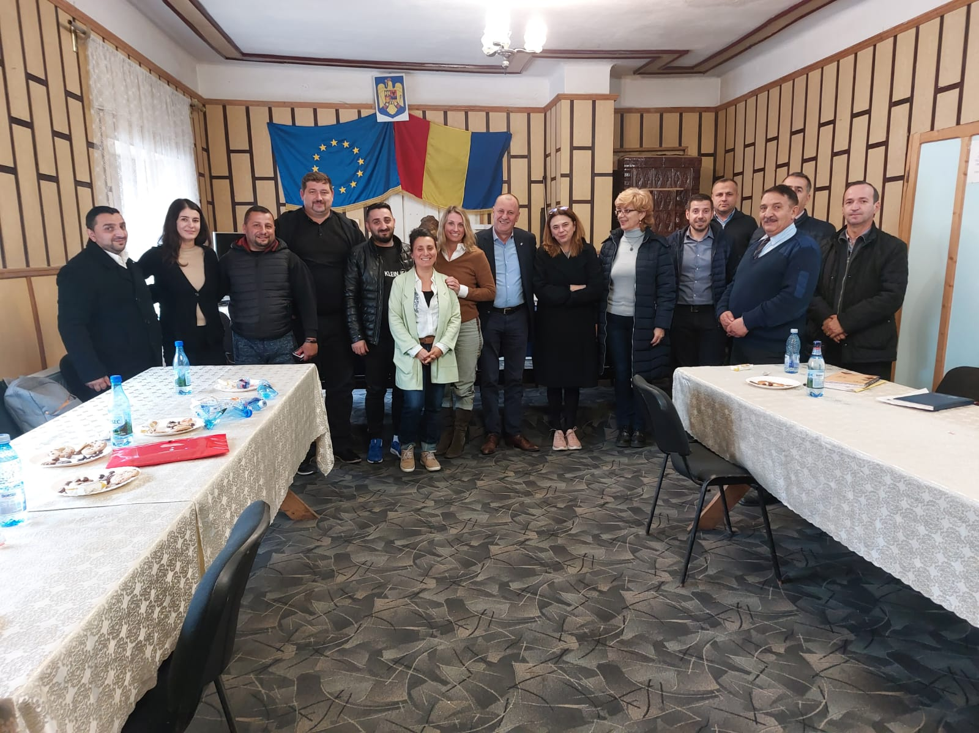

***Roundtable Bărbulești***

***Roundtable Păuleasca***

