OUTPUT Roma Pilots Phase 1

Stakeholders and issue mapping – Bărbulești
Field visit report Phase 1

Contents
1. Introduction 2
2. Community description 3
2.1 Location 3
2.2. Community, housing and living conditions 4
2.3. Key social and environmental risks 5
3. Stakeholder mapping and analysis 6
3.1. Roma leadership 6
3.2. Key local stakeholders and description of social dynamics 7
4. Description of last major flood event (and related natural hazard risks) 9
4.1 Description of events 9
4.2. Actions for preparedness, emergency response and recovery from community and local authorities 10
4.3. Existing practices / systems for coordination for preparedness, prevention and response 10
5. Key issues requiring long-term solutions 10
6. Entry points and opportunities 11
7. Key procedural steps critical for engagement or “Key issues to be addressed at the multistakeholder roundtable (phase 2)” 11

Introduction
This report presents the findings of the first visit in the Roma community affected by floods from Bărbulești and the initial contact with the community and local stakeholders, within the Phase 1 of the Roma Pilots, within the RO FLOODS Project.
The objectives of the visit were to:
- Identify Roma and local leaders, and other relevant stakeholders (SHs) such as representatives from more vulnerable segments of the Roma community (disabled, women, elderly, children) to attain their points of view and understanding around flood risk/social risk and dynamics/engagement with local authorities and seek their participation in all phases of the Pilot.
- Identify the communication network (or lack of it) between stakeholders (community, local and regional authorities).
- Identify the local/ regional representatives with previous experience in the Roma flooded communities.
- Gather on site information on flood events, including the community perspective.
- Gather on site information on flood preparedness, response and recovery measures.
- Identify the stakeholders responsible for possible solutions for the community.
The visit of the community was facilitated by the Buzău-Ialomița River Basin Administration (RBA) who identified key contacts for the filed visits from: local City Hall, county level authorities and the water management personnel under its administration in the area, Ialomita (Slobozia) Water Management System (SGA).
At the county level, discussions were conducted with:
Upper level functionaries from the Ialomita Prefecture, including the minority expert.
The Architect in Chief of the Ialomita County Council, and with two of the representatives of the Inspectorate for Emergency Situations (ISU).
The aim was to collect data about:
1) The status of planning and the legal situation of the community in Barbulesti
2) minority issues in the context of the County Council activities and specific issues for the respective community, and
3) collecting the history of response to floods and the experience of intervention in the Roma community.

The local municipality of Bărbulești served as a key facilitator for the visit in the community and assisted the WB team in collecting all the necessary data and interacting with community members.
Locations and organizations visited:
- Bărbulesti
  - City Hall 14 Jun
  - Roma community – 14 Jun
  - City Hall and neighborhood 15 Jun
  - City Hall and Church 15 Jun
- Slobozia (county capital Ialomita)
  - Ialomita Prefecture 16 Jun
  - Ialomita County Council 16 Jun
  - Ialomita Water Management System (SGA) – 16 Jun
- Buzău
  - Buzău-Ialomita River Basin Administration (RBA) – 17 Jun

Community description

2.1 Location
Bărbulești is a”young” commune, established in 2006, when it was separated from the commune of Armasesti. Now it’s a predominantly Roma locality situated on the banks of the river Sărata, Ialomița County, in the immediate vicinity of the town of Urziceni. The registered population is, according to the 2011 census, of 6.000 members, but the officialities expect that the new census will indicate the real number, that according to their estimations is 11.000. The commune is situated in the immediate vicinity of the European road that connects Bucharest with Moldova, at a distance of around 60 km from the capital.
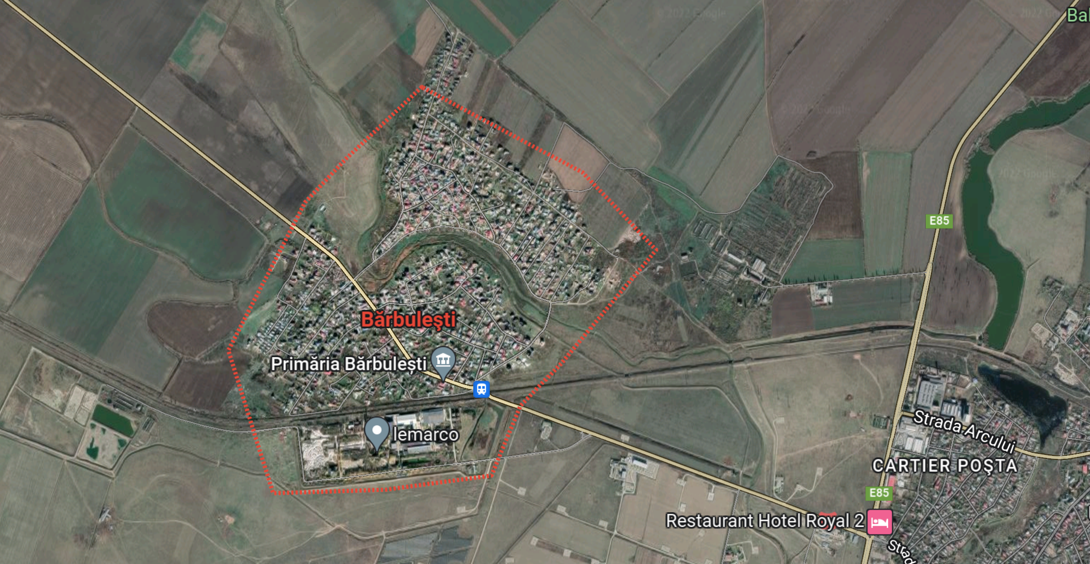
Figure 1 territorial situation and access roads
The settlements on the left bank of Sarata river (in north) are placed on a small hill, but most of the village lays on the right bank in the flood plain, protected by a dike. This is where the last major flood occurred, as the water was higher than the dike and surpassed it. There are two bridges that connect the two parts of the commune, the Eastern one being completely covered by water in 2005.
Most of the inhabitants have access to electricity and water (not drinking water though), and there is no sewage system or other public utilities. There is a relatively operational garbage collection service and there are no important sanitation issues affecting the community.

2.2. Community, housing and living conditions
The community consists of mostly self-declared Roma, native speakers of Romani language, but with a very good command of Romanian as well. The mayor, vice-mayor and the local councillors are all Roma. In this case, the Roma community is very well represented at the local authority level, as they hold the local power. They are traditional Roma, belonging to the ursari subgroup, but there is a tendency towards ”modernization”, i.e. less traditional costumes and alignment to the practice of traditional customs.
This is driven by a significant change in the lifestyle of the community that has two major causes. The first is the strong process of migration (with locals returning to the village a few months/ year) towards Germany and Sweden, where the Roma are integrated in the social welfare system and in the job market. This has a significant impact on the early marriage practice, that is no longer possible since children have to be registered in school and are closely monitored while living abroad.
A second driver is the spread of Pentecostalism among the Roma, a practice that reduced to a minimum the violence in the village. Bărbulești had a really bad reputation for violent crimes, one that the community is well aware of, and that they are now trying to combat. There is a significant number of Roma that are active with religious practices of Pentecostalism.
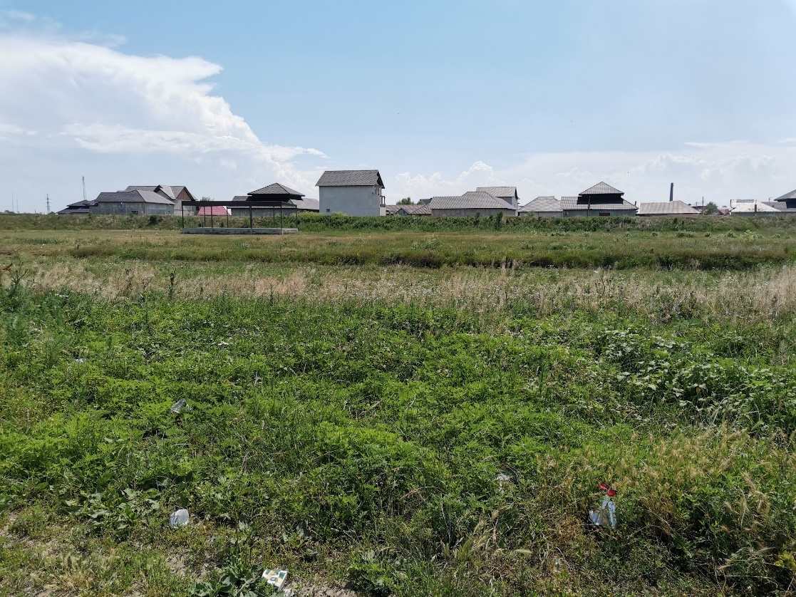
Figure 2 View of the area that was flooded in 2005.
The quality of housing is above average, with some buildings of a higher standard. Most of the buildings that were situated in the area that was flooded were made of clay and were completely destroyed. The new ones are made of bricks and have a concrete structure and regular foundations. Some of them have raised foundations, as a protection measure against floods, but according to local accounts, the water level was at least two meters high, and none of the new buildings is able to withstand a major flood. The flood also produced a displacement of the original Romanian population, that is now replaced by the Roma. It is unclear if the land titles are present, or were achieved in full respect of legal conditions, hence the legal status of the land and buildings has to be verified. However, the situation on the ground is relatively good, the plots are correctly sized and aligned, and most of the constructions appear to be executed in respect of the current building norms.
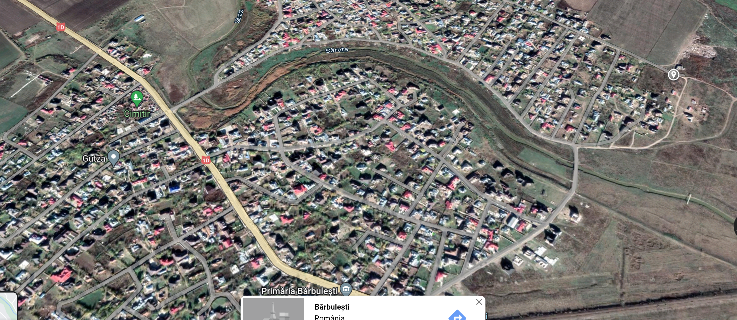
Figure 3 Flood prone area.-the village surrounded by the dike and the road
The severity of the flood event in 2005 that swept off a large part of the territory is still present in the minds of the people, but the younger ones appear to be less aware of the risk. The lower area is not safe for living, but since the Roma have no other place to go, they just returned to their houses and started to repair them.
Barbulești is still a vulnerable community, with many members having a very low level of education, with a very high level of unemployment and residing in a mono-ethnic area. Many buildings have an uncertain legal status and almost half of the community being located in a flood prone area.

Flood risk
According to the specialist from SGA, the mechanism of the flood that affected the community in 2005 is well known and understood, the protection measures are significant, but this not eliminate the chance to have another similar event. The key issue stands with the particular position of Barbulești at the confluence of two rivers, and in the dynamic of the flood waves on Ialomița and Prahova, that is regulated by the Dridu accumulation. This is acknowledged by the community, but not fully understood, and the flood risk needs to be better explained to the community. The local administration strongly highlighted the need for better protection.

2.3. Key social and environmental risks
Racism. A compact Roma community is subjected to many stereotypes, and in particular Bărbulești, who has a history of a relatively intense criminal activity, has to deal with a poor image. What could be an asset in fighting the prejudices is that we could observe, and confirm through discussions with the villagers, that the life in the village is safe and calm, and that the living standards are decent and sometimes higher than the average.
Unemployment. There is little work available in the area, a huge percentage of the inhabitants live and work abroad, some of them on the expense of the welfare systems of Northern Europe. Due to a very low level of education the jobs that they can get are poorly paid in general. There are some local business in construction and commerce, but they only employ men. However, there is little poverty visible in the village, but the prosperity is a bit fragile, and relying on migration and local business.
Low level of education. Though children go to school, there are very few graduates, and even fewer would go from secondary school to high school. There is no ethnic mix, since the percentage of Roma reaches now almost 100%.
Low level of access to healthcare. There are two health mediators that helps some of the most vulnerable members of the community to get access to healthcare.
Segregation. The area is still perceived as dangerous and is now a mono-ethnic settlement. According to the mayor, his requests to the upper-level authorities (County Council and Prefecture) are largely ignored and he perceives this as a discrimination.
The community experiences two main threats:
- Floods: an entire housing area comprising several hundred families was rebuilt in the area that was destroyed by the previous major flood.
- Lack of administrative capacity: the City does great efforts to keep the personal, collect taxes and organize the community, however their management capacity is exceeded by the issues they have to address. There is a strong will to prepare for the flooding, but little capacity.

Stakeholder mapping and analysis

3.1. Roma leadership
The Bărbulești community is a traditional ursari community with a unique level of leadership. The internal divisions appear to be moderate, following a division in religious practices, but this has no major impact in the way in which the community works.
Roma community stakeholders
At the local level, the following key Roma leaders have been identified:
- The Mayor
- The vice-Mayor
- Pentecostal pastor
- Orthodox priest
- Other local leaders
- Volunteer group
The Mayor
Given that the Roma community is fully represented in the local council, the problems that they face are in relationship with other state institutions at the regional level and central level. The mayor is involved with the political leaders at the county level, as he belongs to the same political party, but this is limited to electoral activities.
The vice-mayor appears to represent a strong local force, and the mayor is very keen to show that they have an alliance that is fully operational. The vice-mayor appears to be the most proficient person in what regards administration businesses but, as mentioned, they have to rely on very few employees.
The local leaders are not members of the Roma Party, the internal organisation largely following a complex kinship pattern. All the persons present in the Mayor’s office during our three meetings (political actors or not) welcomed the idea that they should be actively engaged in the flood risk prevention, planning and response engagement processes.
The Pentecostal Pastor. The church is very active and works as a community centre that collaborates closely with the City Hall. The leader of the church provided us a history of the response to flood that described the action of the community in terms of solidarity.
The Orthodox Priest is one of the few Roma priests in Romania. He is very active in his community, but since the local leadership is entirely dominated by the Pentecostal he was not invited to the talks. However, the religious division is not very strong and does not affect the response to floods or the preparedness measures.
Local volunteer group, is organized according the ISU’s plans, but it is unclear how well trained or active they are. During the flood events of 2005 and the minor events of 2014 there was always a very good mobilization of the inhabitants, regardless of them being part or not of the volunteer group. There was an intense solidarity based on family affiliations during the floods, and a reasonable expectation that this will function in the eventuality of another major flooding event.

3.2. Key local stakeholders and description of social dynamics
- ABA Buzău-Ialomița
- SGA Slobozia
- Bărbulești City Hall
- Penticostal Church
- Ialomița County Prefecture
- Ialomița County Council
- ISU Ialomița

Local authorities
The commune is increasingly active in what regards the public works needed to improve the quality of life at the local level. The local administration strongly highlighted the need for better protection.
Consolidation works were done for the access road to the higher parts of the village (the river terrace, where the river bed ends), also a promenade was built alongside the river. These were done using local funding and issuing building permits at the local level; however, they were not coordinated with the County and the water management authorities. A potential problem lies in the fact that the promenade is built on top of the protection dike, which is illegal, and can affect the structure and integrity of the flood protection works. Locals take great pride in that area, the only public space they have, but are not aware of the technical issues that are involved.
Following a different type of event, a blizzard that blocked the European road, the City plans to improve the capacity to host refugees. They already bought beds, but they are looking for an accommodation space, for now the school being the only available construction. The event also highlighted some of the existing racism at the population level, the Roma were ready to help people that were in danger and were met with suspicion. This was an important occasion for them to show their hospitality and solidarity.
The Mayor and his team highlighted the utmost importance of increasing the flood protection capacity of their commune, even mentioning that they are ready to add one meter to the dike on their own money. Also, according to their account, the volunteer team is operational and they managed to update the preparedness plans with ISU.

County authorities
- The Ialomita County Prefecture highlighted their competencies and responsibilities in what regards this sort of situations but also the fact that they have no direct experience with the community or the major event of 2005. No person with a more direct or deeper knowledge could be identified at the Prefecture, somehow logical considering the relatively long time since the last major event and the high fluctuation of personnel. There is a proactive attitude at the Prefecture level, they were very helpful in what regards mobilising the persons in charge and establishing local connections.
- The Minority County Expert also took part in the meeting, he did not provide too many details about the work with Roma from Bărbulești, but instead he presented a larger picture of Roma issues at the county level.
- The architect in chief of the county was interested in the Flood Hazard and Risk Maps and the correlation with the County planning documents. She was also very well aware of the planning issues in Bărbulești. She showed a significant interest in the subject matter, she also highlighted the difficulties of discussing technical issues at grass root level, and the legislative gaps that are affecting the possibility to legalize the informal parts of the community.
- The ISU representatives exposed their activity and the general structure of intervention in the case of flooding. They were not with ISU at the floods event from 2005, but very well aware of what to do as preparedness measures. They were willing to create a dialogue with the Roma community and promote preparedness measures.
The County level institutions are aware of the situation of the community, but our discussions showed that there are no current plans to address Roma issues, a general attitude of mistrust prevailing when it comes to Roma. Nevertheless, our proposal for the second phase meeting was accepted and almost all of the points we raised were considered worthwhile.

Water authorities at regional and local level
- RBA Buzău-Ialomița. Concerns and complaints regarding the interaction with the local authorities were expressed, there was a very slow response of the local authorities in what regards the meetings.
  - SGA Ialomița representative showed an advanced understanding of the social, legal and physical context and it’s the only person that had an interaction with the place and the local authorities, even if very limited. Despite the fact that he was not an employee of SGA at the time of the event, he did a proper archaeology of the flood in order to understand what has to be done. He showed interest, but also highlighted the possible limits in working with Roma communities and has no experience with other Roma communities. The SGA is key in what regards the work with this particular Roma community as they are the closest water management authority and could provide assistance in optimizing the maintenance activities.

Description of last major flood event (and related natural hazard risks)
  - description of events
  - actions for preparedness, response and recovery at the specific event
  - SHs involved and identified roles at the specific event
  - roles of SHs as perceived by community
  - description of existing practices and coordination for flood risk events

4.1 Description of events
The last major event occurred in September 2005 and led to the destruction of at least 200 houses and to the displacement of around 2000 people. 300 of them took refuge in the school, but the area was also flooded later. Many others that had to sleep in the attics of their houses, but for a significant number of them this that was a major problem since the houses were made of adobe and many of them collapsed. A significant percentage of the population went to their extended families who lived in the upper part of the village or in the villages around. They stayed there for months and even years until they were able to rebuild their houses. The help of the extended family is the first and main emergency plan the locals mention in relation to flood.
A major problem was that the settlement was divided by the flood and that from a certain point in time taking refuge on the hilly side was only possible making a huge detour. Water retreated very slow, the recovery process was long and led to the disappearance of the Romanian community, that now only numbers four families.
According to the SGA representative, other minor events took place in 2014 and 2019, but were not even mentioned by the local authorities.

4.2. Actions for preparedness, emergency response and recovery from community and local authorities

Warning: RO alert system
In 2005 RO alert system was not available. The locals and authorities mentioned other forms of alert: church bells, driving around the village and announcing the danger through megaphone, word of mouth, etc.
Emergency response and recovery:
During the flood the gendarmerie and a private security company intervened. The first response came from the local Roma leaders and volunteers. One media source mentions three victims, we couldn’t conclude on the official number of casualties, but it is clear that many lives were in danger.
The evacuation process had several phases:
- In the first hours people took refuge in the attics, and some were sheltered in the school, which was later flooded and isolated for two days. Many were still trying to cross the flooded bridge, the authorities intervened and directed them to safety.
- The following days several hundred community inhabitants were sheltered by their neighbors or by their families. The school was also evacuated.
Some houses were rebuilt with materials provided by the state, and a few dozens of 3 room-houses were built by the government and the locals latter on added more rooms. An intense process of exchange of terrains started and the properties were reconfigured and changed their owners. After the accession of Romania to EU, many Roma migrated, then returned after few years and started to build new houses

4.3. Existing practices / systems for coordination for preparedness, prevention and response
The ISU has a well-developed emergency response plan. However, the volunteer group on which ISU relies is very small, and the burden lies on the local solidarity, very strong but with no particular training and understanding of proper procedures.

Key issues requiring long-term solutions
After the first visit the preliminary assessment showed that there is no planning regarding the structural issues that are creating the emergency situations or for developing sustainable urban planning solutions. These are issue that need to be put on the agenda in the second phase.
The key issues aggravating the flood risk for this community and their adverse impacts identified in this first phase of the pilot are:
- the semi-formal status of some houses and plots: the community is not an informal settlement, however, not all legal papers are present, mainly building permits.
- the lack of proper urban planning
- the need for a higher level of protection against floods
- the lack of community education on preventative and preparedness measures
- lack of an education in what regards the emergency response at the community level. The preliminary assessment indicates that flood risk management in the community could benefit from improvements on dialogue, solving conflictual relations, building trust and working on a community practice informed preparedness plan.

Entry points and opportunities
- A positive practice in regards with the first response to an emergency.
The multiple points of view collected showed that lives were saved due to a fast response of the community, of the authorities and of some volunteers. Unfortunately, since no solution to structural problems was developed, and just the dikes were repaired, the situation can repeat at any time.
- Technical understanding of the hazard
All the non-technical parties showed a great interest in the technical solutions to the problem, and a fairly good understanding of the flood mechanism. This topic can be used to channel the discussions in a constructive way.
- Local and county level representation of the Roma
This is a rare case of an exceptionally good representation of the Roma at local level, but with no success at the upper levels. The representatives have some experience in interacting with county authorities and a fairly good understanding of various legal and technical aspects. The main task is not only to put the community on the main agenda of the County, but also to improve the local capacity to deal with administrative issues.

Key procedural steps critical for engagement or “Key issues to be addressed at the multistakeholder roundtable (phase 2)”

The role of authorities in solving the legal issues of the community
  - Presenting the role of the RBAs in the larger planning activity at the county and regional level
- Reconfirming the role of every actor involved in the first response activity, (i.e. enlarging and testing the mechanism established by ISU)
- Giving voice to the Roma community in front of county authorities
  - Reinforcing the role of the community leaders
  - Discussing the internal points of view within the community
  - Providing them the minimal information that is needed in order to engage into a fruitful debate about flood risk management
  - Including women, the elderly and the young into the second phase meeting
- Enhancing the capacity of water management authorities and ISU to engage with the Roma
  - Non discrimination, not just in response to floods, but also long-term planning
  - Preparedness – ensuring that the volunteer teams are fully operational and that the community is prepared as well
  - Planning for maintenance activities, insuring workers’ and machinery protection
  - Support for the improvement of the water safety and the quality of life in the settlement

