OUTPUT Roma Pilots Phase 1

Stakeholders and issue mapping – Roșia Montană-Dăroaia
Field visit report Phase 1

Contents
1. Introduction 2
2. Community description 3
2.1 Location 3
2.2. Community type & form of organization 4
2.3. Key social risks 6
3. Stakeholder mapping and analysis 6
3.1. Roma leadership 6
3.2. Key local stakeholders and description of social dynamics 7
3.3. Analysis of existing levels of power, interest, trust and engagement 9
4. Description of last major flood event (and related natural hazard risks) 10
4.1 Description of events 10
4.2. Actions for preparedness, emergency response and recovery from community and local authorities 10
4.3. Existing practices / systems for coordination for preparedness, prevention and response 11
5. Key issues requiring long-term solutions 12
6. Entry points and opportunities 12
7. Key procedural steps critical for engagement or “Key issues to be addressed at the multistakeholder roundtable (phase 2)” 13
8. Annex 14

Introduction
This Report presents the findings of the first visit in the Roma community affected by floods from Roșia Montană-Dăroaia and the initial contact with the community and local stakeholders, within the Phase 1 of the Roma Pilots, within the RO FLOODS Project.
The objectives of the visit were to:
- Identify Roma and local leaders, and other relevant stakeholders (SHs) such as representatives from more vulnerable segments of the Roma community (disabled, women, elderly, children) to attain their points of view and understanding around flood risk/social risk and dynamics/engagement with local authorities and seek their participation in all phases of the Pilot.
- Identify the communication network (or lack of it) between stakeholders (community, local and regional authorities).
- Identify the local/ regional representatives with previous experience in the Roma flooded communities.
- Gather on site information on flood events, including the community perspective.
- Gather on site information on flood preparedness, response and recovery measures.
- Identify the stakeholders responsible for possible solutions for the community.
The assessment of the community was facilitated by the Mureș River Basin Administration (RBA) who identified key contacts for the filed visits from: local City Hall, county level authorities and the water management personnel under its administration in the area: Alba Water Management System (SGA) and Turda Hydrotechnical System (SH).
At county level, discussions were conducted with the Architect in Chief from Alba County Council, with the Roma County Office (BJR) representative who is the minority expert under Alba Prefecture, and with the representative of the Inspectorate for Emergency Situations (ISU).
The aim was to collect data about:
1) plans for changing the status of the community from informal to formal settlements
2) minority issues in the larger context of the County Council activities and specific issues for the respective community, and
3) collecting a brief history of response to floods and the experience of intervention in the Roma community.

The local municipality served as a key facilitator for the visit in Roșia Montană-Dăroaia and the WB team built their assessment based on expert knowledge and on the interviews with the community members.
Locations and organizations visited:
- Dăroaia (Roma neighborhood affected by flooding in Roșia Montană commune)
  - Roma community – 14 May 2022
- Roșia Montană (commune, Alba County)
  - Commune mayor’s office – 15 May 2022
- Alba Iulia (county capital)
  - Alba Water Management System (SGA) – 17 May 2022
  - Alba County council – 16 May 2022
  - Alba Prefecture – 16 May 2022
- Turda
  - Turda Hydrotechnical System (SH) – 17 May 2022

Community description

2.1 Location
Dăroaia is a predominantly Roma neighbourhood situated on the left bank of the river Abrud in the commune of Roșia Montană, Alba County. It is located in the Apuseni Mountains and has a population of approximately 700 members, including 250 children. It is situated between two larger localities, Abrud and Câmpeni, small cities with a large suburban territory. The commune used to be a very important mining location, now in a radical decline due to issues related to the exploitation contracts from the recent years. This also led to a major reduction of the Roșia Montană population and to the disappearance of the local industry.
A part of the commune is classified as a UNESCO heritage site, being considered “the most significant, extensive and technically diverse underground Roman gold mining complex known at the time of inscription”. The UNESCO status limits the extent of changes that can be done on the local built environment and industrial patrimony. For example, there is a train line that runs through the middle of the community, as well as a bridge that connects the Roma settlement with the rest of the village, both being listed as National Monuments.
According to the local population, the Roma settlement was established in the 1950s and has been growing ever since. The Roma settlement is situated on the left side of the river Abrud, a few meters away, partially separated by a concrete protection wall. This is followed by the first terrace, on which a narrow line railway runs, then by a line of houses very close to the railway and climbing up a very steep hill, covered by a forest that is crossed by several streams. The Abrud river poses a significant flood risk and has been a source of fluvial floods as well as flash floods in the past. Another flood risk are the forest streams which increase their debits and velocity during storms as they come down steep hills, some crossing the Roma settlement, and flowing into the Abrud river.
The Roma settlement is connected to Roșia Montană commune by two access points. The main access point is a historical riveted bridge, part of the protected historical area, and can only be accessed by foot. The second access point is a road that also intersects the railway and connects relatively far with a local road. This was also the spot of a traffic incident in which one community member was injured. This incident has put the community in a conflict with the railway owner but the railway line is still active.
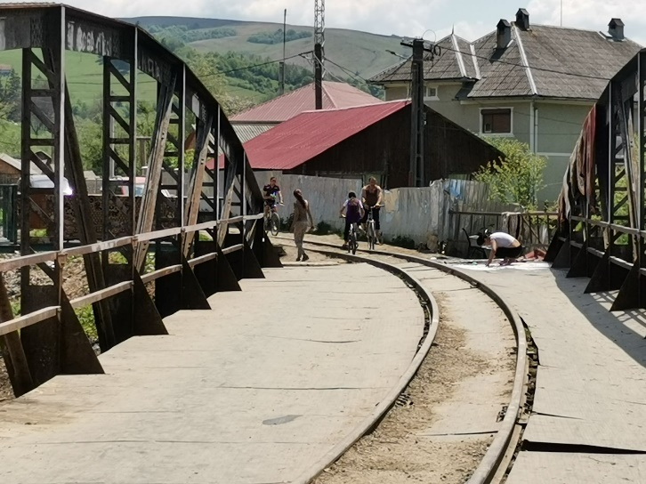
Figure 2 Main access on the hystorical bridge and, on the right, a water pump, the only water source for the community

The only local infrastructure available for the Roma community represents intermittent electricity service and a public water pump, which is the only source of clean water for the entire Roma community. Before the floods, they also used water from a stream, possibly not fit for drinking.
Next to the community location, there is a major mining facility now abandoned and in an advanced stage of dereliction. On this location the emergency shelters (containers) for the community members affected by flood were placed. The permanent Roma settlement does not have a sewage system, an operational garbage collection service and there are important sanitation issues effecting the Abrud river which experiences clogs, due to the waste piling up.

2.2. Community type & form of organization
The community consists of around 700 members (who only kept Romani language from their Roma cultural heritage) who live on a narrow strip of land that stretches for about 250 meters, most of them living in the first 180 meters, in approximately 100 shelters and houses. The quality of housing is varied, ranging from a regular rural standard with brick and mortar to improvised wooden and metal barracks.
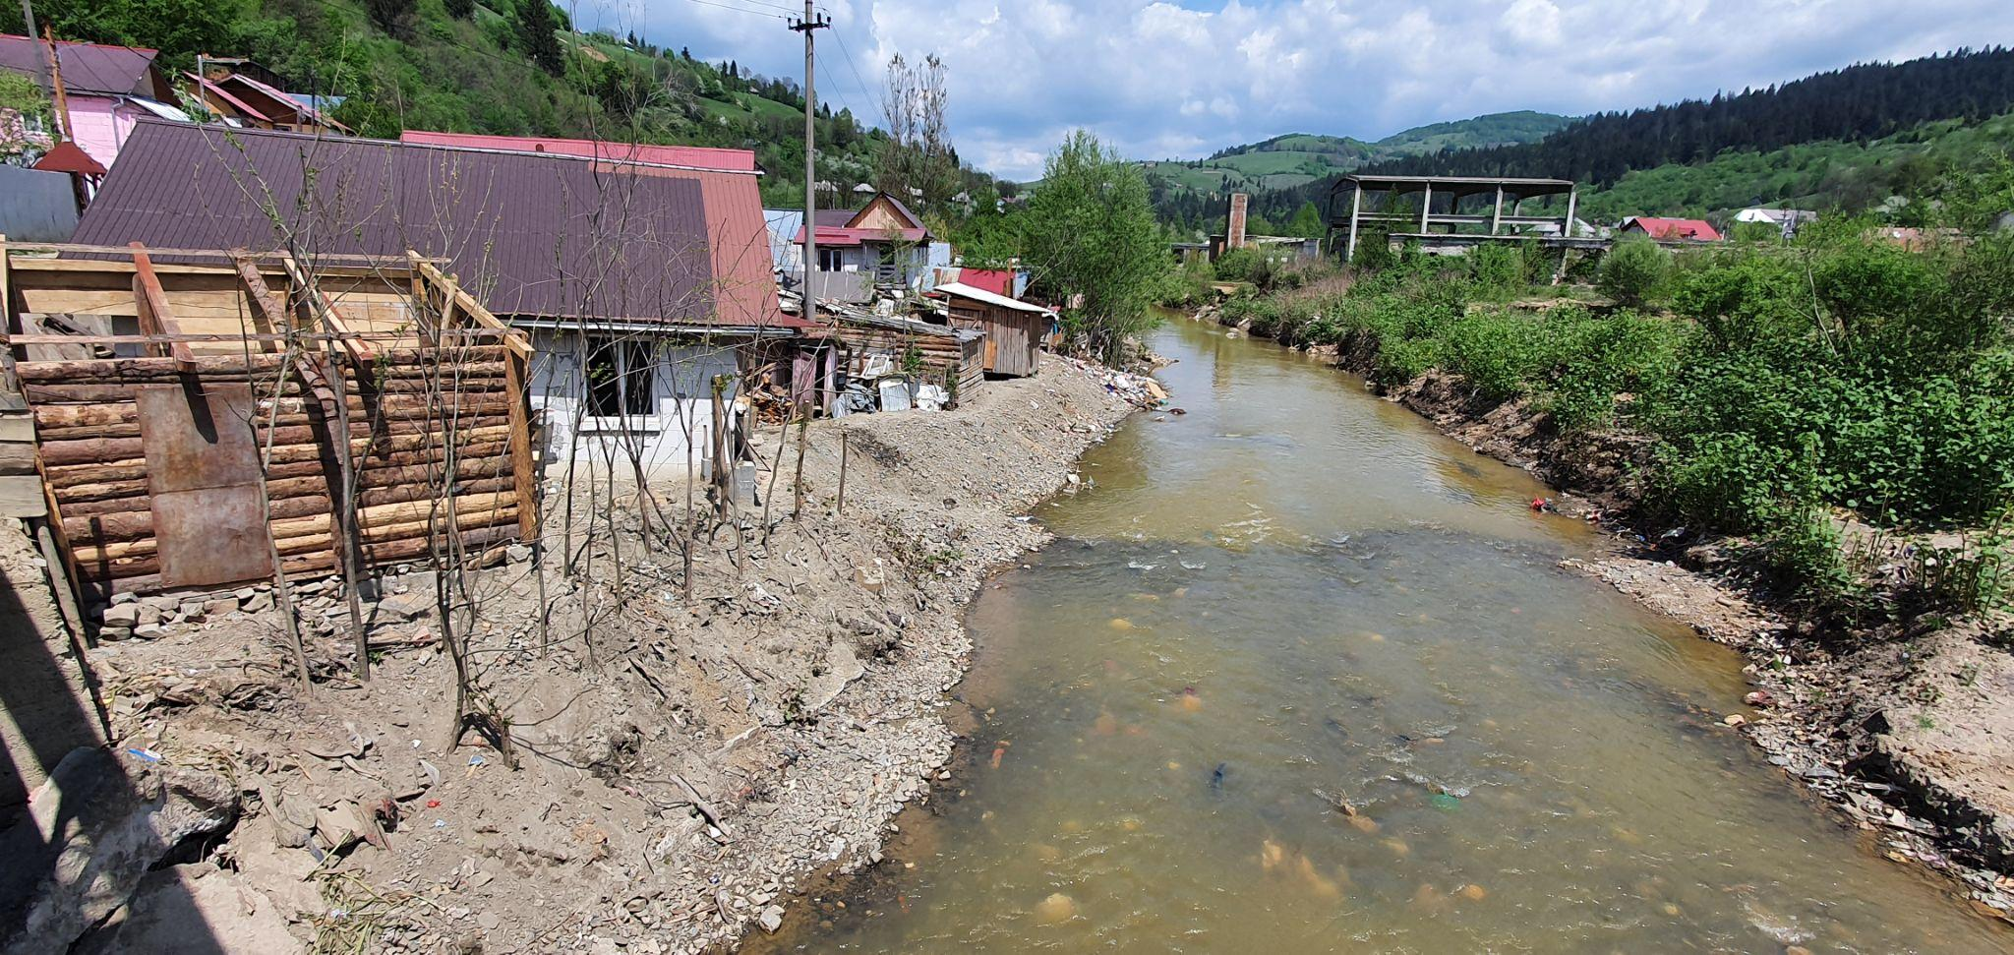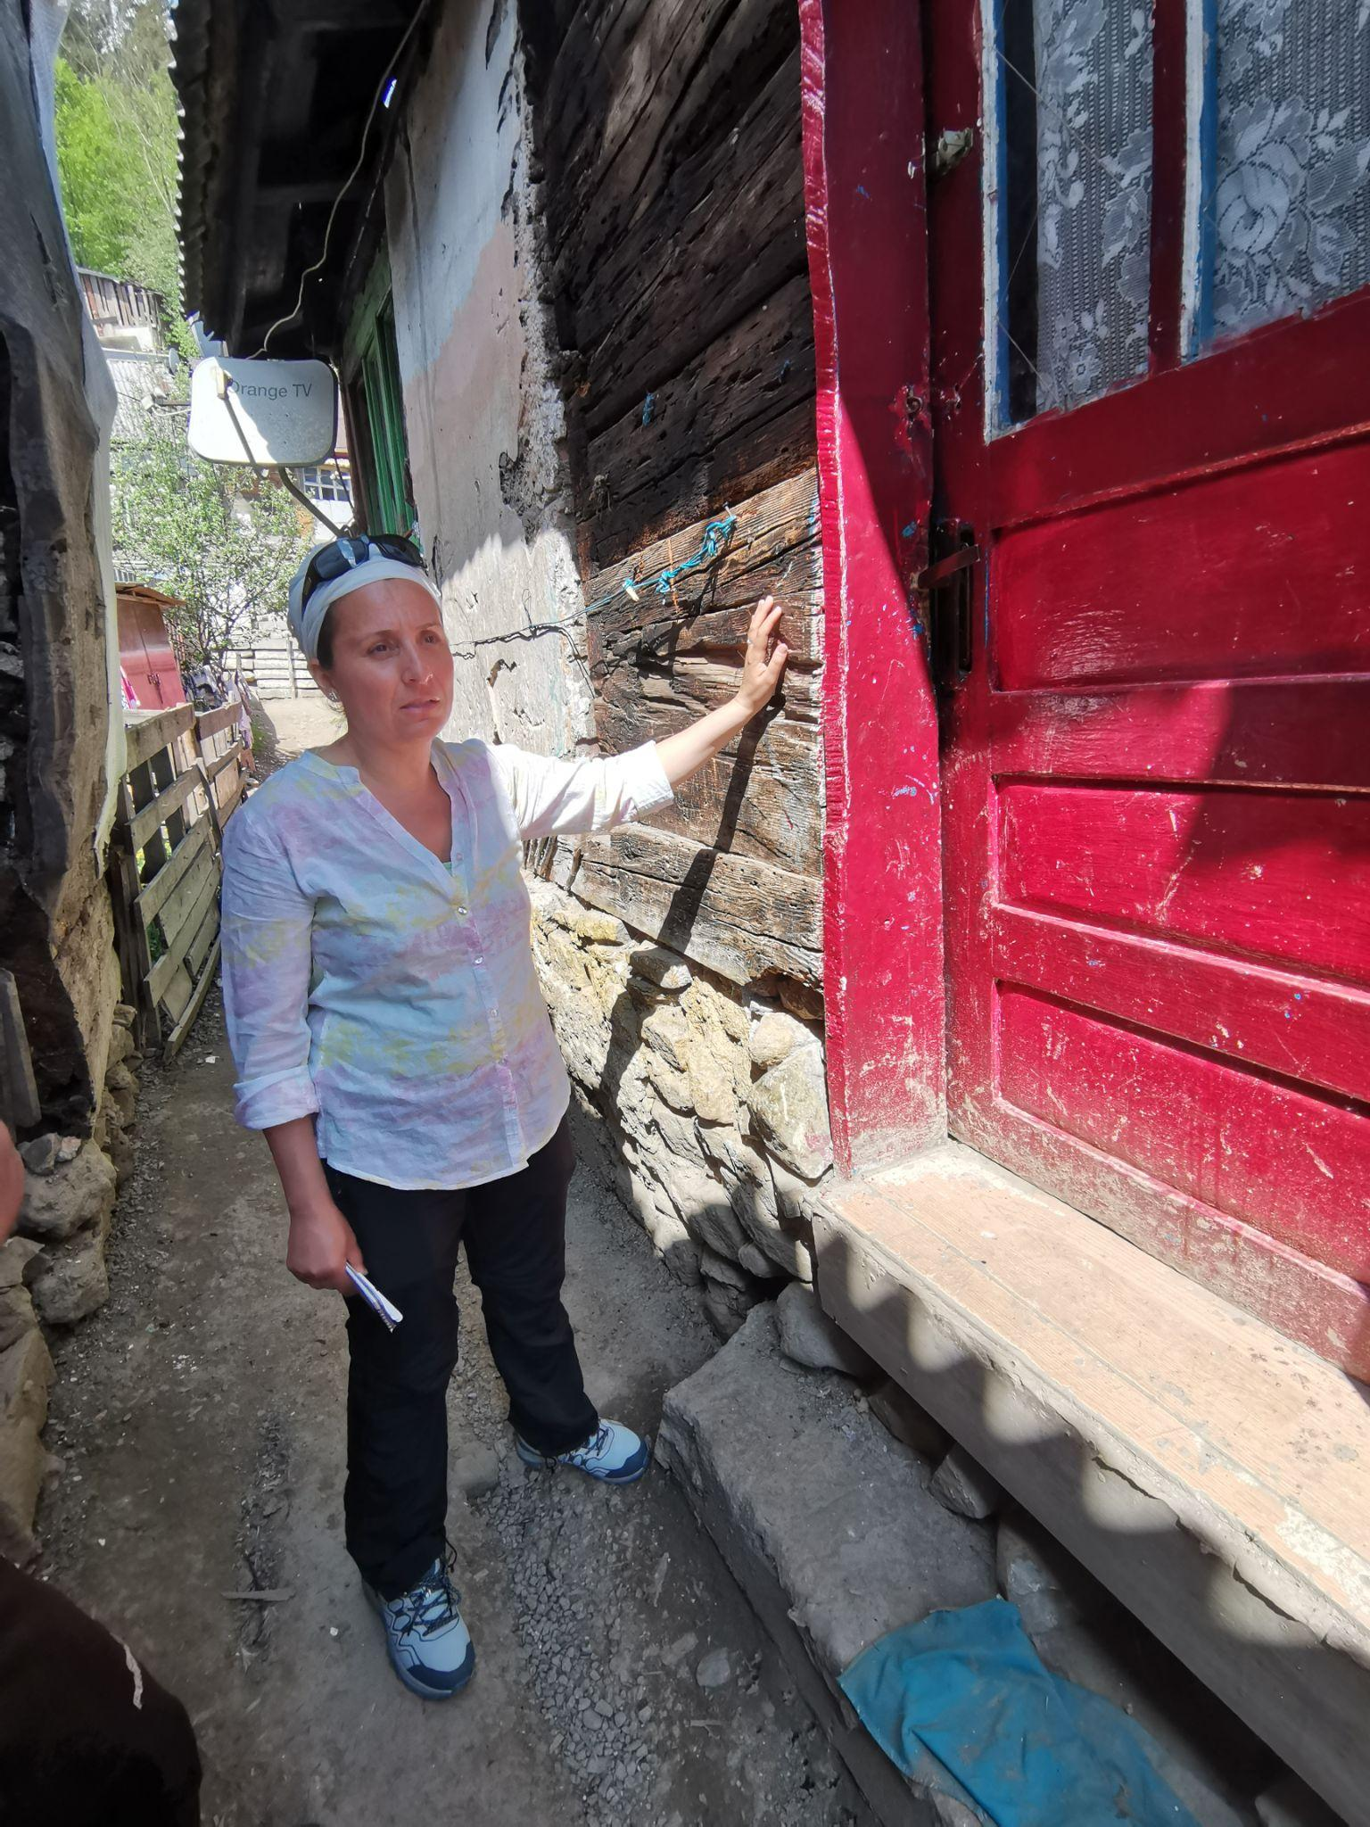
Figure 1Main view from the bridge across the river (left), and the level the water reached during the flood (right).
Romani language is spoken “in the house”, but Romanian appears to be the main language and is used with ease by the inhabitants. The elderly seem to hold higher levels of education than the youth. This is probably an effect of their historical interaction as industrial workers with outside companies, and most people have advanced skills of social interaction. This particular Roma community shows a significant level of equality between members, including women, most members being allowed to take part in discussions and express their opinions. In this sense, this is not a traditional community, but a modernized one, with a higher level of education than usual in marginalized Roma settlements and an open attitude towards interactions with external stakeholders.
The relative geographical isolation of the community and the lack of strong links with traditional communities has kept this community somewhat isolated from the mainstream Roma minority movement, although the current Roma community leadership is very much involved and supported by the Roma Party.
Due to the severity of the landslide during the flood event that swept off households, the community was assigned the status of “auto-evacuați” (self-evicted). This is in opposition to the evicted status which would put certain responsibilities on the town hall. The self-evicted status implies that the settlements are not recognized at all, and the authorities have no responsibility in taking care of the community. The entire area is not safe for living, but since the Roma have no other place to go, they just returned to their houses and started to repair them. At the next flood event, the landslide could occur once again with the same devastating results. Consequently, the Roma people are “self-evicted”, a compromise solution that has the meaning that they are aware of the risk and the authorities cannot be made responsible. The alternative would have been a full resettlement of the community, but no research has been done to date, by local authorities or other stakeholders, to understand what the prerequisites of the community would be to accept resettlement.
Daroaia is a highly vulnerable community, with many members facing destitution, with a high level of unemployment and residing in an area affected by massive population and economic shrinkage. The community has an uncertain legal status, with no property rights and being officially ”self-evicted”, which from a legal perspective means the Roma are not recognized by the authorities as inhabitants of the area.
Flood risk
Dăroaia, the Roma community in Roșia Montană, faces two major hazard risks, including floods and landslides. Flood risk threatens the houses built directly upon the riverbank, just a few meters away from the Abrudel river. The Abrudel river’s tributaries are collecting the mountain streams that during storms are prone to flash floods. At the same time, with heavy storms, landslides threaten the houses built at the base of the hill, across from those build along the riverbank. The phenomena of landslides are newer, with the first major landslide being reported by the community in 2021.

2.3. Key social risks
Racism. The widespread attitude towards the local Roma reproduces all the stereotypes that can be found across Romania: „they live like that because this is their culture”, „they do not work/ wake up / study etc., like the rest of us”, „they have too many children and they make a living out of this”, etc.
Unemployment. There is very little work available in the area, a huge percentage of the inhabitants left the Rosia Montana commune since the mine closed. Many of the Roma were employed as auxiliary personnel there, but due to a generally low level of education, professional conversion is difficult. The entire area is affected by population and economic shrinkage, but the Roma carry the burden of long term material deprivation.
Low level of education. Though the children go to school, there is a visible segregation in the local school, which started to be frequented solely by Roma. Very few graduates from secondary school go to high school.
Low level of access to healthcare. There is a health mediator that helps some of the most vulnerable members of the community to get access to healthcare, but the general situation of medical services in the Apuseni mountains is dire. One of the problems that could be observed is the high number of dependents.
Segregation and spatial deprivation. According to the relatively new addition to the Urbanism Act 350, namely Legea 151/2019, the area is considered an informal settlement, and should be taken into consideration as such.
The community experiences three main threats:
- Floods: most of the houses are built a few meters away from the river.
- Landslides: deforestation and other works done on the hill right above the houses appear to have an increasing risk to the community.
- Railway accidents: the railway running through the middle of the community being used as the main access for all the inhabitants.

Stakeholder mapping and analysis

3.1. Roma leadership
The Dăroaia community is moderately divided, and it shows a level of leadership that is above the current average. However, the internal divisions are relatively strong, a fact that is important to take into account within the stakeholder analysis and any engagement with this community.
Roma community stakeholders
At the county and local level, the following key Roma leaders have been identified:
- a Roma Party County leader.
- president of Roma Party Rosia
- vice president of Roma Party Rosia
- president Roma NGO “Pakiv”
- Roma Minority deputy
- a Roma school counsellor,
- a local counsellor,
- a local Roma Party organization and
- Vulnerable groups within the community: women; young and the elderly people
Given the community has representatives in the local Roma parties, several counsellors, a deputy and it can be inferred that there is strong leadership at the local and regional level and the local leaders are entry points into the community who should be actively engaged in the flood risk prevention, planning and response engagement processes, as further detailed below.
The leader of the Roma party at the County level is a person with advanced understanding of the administrative and legal system and can serve as an important partner in these processes.
The vice president of the Roma party is also the leader of a large family that was seriously affected by the 2021 flood. He fears a ”water bubble”, allegedly located in the hill above. It is unclear where the water bubble hypotheses emerged from, but the mayor also mentioned it. According to this, there is a major accumulation of underground water on top of the hill that could potentially create both a flood and landslide at any moment.
The ”opposition” leader, a former NGO staff, very active and in contact with other county level leaders.
Roma school counsellor, from the same family as the leader of Roma party, very knowledgeable on legal issues and active in term of children school education.
Local volunteer group consisting in 3 members from Roma community.

3.2. Key local stakeholders and description of social dynamics
- ABA Mureș
- SGA Alba
- SH Turda
- Roșia Montana City Hall
- Partida Romilor Roșia & Alba
- Alba County Prefecture
- Alba County Council
- Roma Minority Deputy
- Pakiv Alba (Roma NGO)
- Ministry of Culture
- Ministry of Environment
- Asociația Rosia Montana in Patrimoniul Mondial
- ISU

Local authorities
The commune of Roșia Montană faced long and complex legal issues in the last twenty years, around the massive gold reserves of the commune and the ancient and more recent patrimony that led to Rosia being identified as a UNESCO heritage site. As a result, the Master Plan of the commune was suspended and can only be elaborated under the special supervision of the Ministry of Culture. This situation adds to the difficulties of planning and limits the potential interventions possible within the Roma community.
- The mayor is open to the idea of hosting discussions among various participants regarding the improvement of the situation in the Roma community, and he is aware of the existing limitations.
- The vice-mayor is the one in charge with the local emergency team and has a good reputation among the Roma, as he was one to directly help save lives during the events.
- Under the vice-mayor there is an emergency response local coordinator. He has no designated members from the Roma community in the volunteer team, but he managed to collaborate very well with some of the locals in order to save the most vulnerable when the events occurred. He is maybe the person that could facilitate the dialogue of the RBAs with the community.

County authorities
- The president of Alba County council was very knowledgeable of the flood event. He highlighted some of the most important factors that are leading to this sort of situations, the informality, the lack of funding, local cooperation issues.
- The architect in chief at county level was interested in the Flood Hazard and Risk Maps and the corelation with the County planning documents. The architect in chief of the County Council was contacted by RBA in order to enhance the collaboration and develop a long term solution. She showed a significant interest in the subject matter, but also highlighted the difficulties of discussing technical issues at grassroot level.
- At the Prefecture level two sub-prefects kindly acknowledged our requests to create a dialogue with the Roma community and between several stakeholders.
- The Roma County Office (BJR) representative, who is the minority expert under Alba Prefecture, also took part in the meeting and provided details about the work of the commission that evaluated the damages. The Prefectures used to have a Roma expert, now they employ a minority expert, who is sometimes a Roma person. In this case, there is a non-Roma dealing with Roma issues, but he is in close contact with local Roma activists. The Prefecture minority expert organized the commissions that distributed various sums of money and materials for the reconstruction of the houses.
The regional level is well aware of the situation of the community, but the preliminary assessment indicated that there are no current plans to address the overall Roma issues.
Water authorities at River Basin, regional and local level
- RBA Mureș was not able to go ahead with the meeting. They will be followed up with telephonically.
- SGA Alba showed an advanced understanding of the social, legal and physical context and proposed meetings and specific training sessions with the community.
The local coordinator manifested a great interest in working with Roma communities and has experience in a different Roma community, where a few lessons learnt can be applied in this case too:
  - communication with community was efficient due to the local Roma leader
  - the Roma community are willing to collaborate with the technical teams as they appreciate their intervention of clearing the ways with heavy machines
  - for future planning suggestions: prevention done together with community through meetings, presentations of the dangers, etc. activities the SGA is willing to undertake
- SH Turda. The SH has the main role in coordinating the intervention during and post-floods on site.

3.3. Analysis of existing levels of power, interest, trust and engagement

The local leaders have good personal contact with the local authorities and were visited on numerous occasions by the county level authorities, in the aftermath of the flood event. Despite that, the level of mutual trust is low. Communication appears to be good during the flood and during the first phase of sheltering but slowly degrades over time. The community also has concerns regarding the transparent use of funds.
Below is a brief mapping of the levels of Power and Interest of the identified stakeholders. Power refers to the power of implementing preparedness, response and recovery activities for flood risk management in the Roma community, while interest refers to the stakeholder’s interest in delivering such activities in the Roma community.

While the RBAs are the water authorities which are actively involved in RO-FLOODS, it is the subordinated levels that have direct responsibilities in the field at community level, namely the SGA and SH. The SGA Alba is the water authority stakeholder with the highest level of interest and power in the community. The SGA can and has expressed interest in delivering community training and tailor-made activities for flood prevention, preparedness and response. However, their power is limited as some roles in flood risk management at community level, such as small but effective protection measures fall under the responsibility of local or county authorities.

ISU is being perceived as people who show up first, with the first response, who are helping the locals but have limited power in the entire process of prevention and aftermath.
Another category of stakeholders that have high level of power but insufficient interest are the local and county authorities stakeholders, namely the mayor, vice mayor, county council and prefecture. Their interest is insufficient as proven by the ‘self-evicted’ status that was given to the community, while their power level is the highest as they would be the authorities responsible for relocation or other community level flood protection and preparedness.
Finally, the Roma leaders, local emergency response coordinator, Roma NGO Pakiv, are all stakeholders with high level of interest in community flood risk management, but have low levels of power, as they have neither the expertise nor the means to devise and implement protection or preparedness measures.

Description of last major flood event (and related natural hazard risks)
  - description of events
  - actions for preparedness, response and recovery at the specific event
  - SHs involved and identified roles at the specific event
  - roles of SHs as perceived by community
  - description of existing practices and coordination for flood risk events
The Dăroaia location has a significant flood risk, addressed by the community with one protection wall, most probably put in place by the town hall, which does not provide sufficient protection on the long term and at major flood events. The situation is aggravated by the deforestation of the area that is right above their settlement.

4.1 Description of events
The last major event occurred on July 16th, 2021 and had two phases.
Community members first noticed the water in the early morning at 4:30 when the lower side of the settlement started to be flooded and the water level on the main course of the river started rising above the danger level. This was not seen as very dangerous by the inhabitants, as it occurs several times per year. There was a general mobilization in the community and the community members took action to contain and limit the flood waters.
As mentioned before the settlement is situated on the left side of the river, partially separated by a concrete protection wall. It is worth mentioning that most of the water was accumulating because of the protection wall that was acting as a retention wall.
Later on, in the afternoon, at around 16.00, the rainfall intensified to (allegedly) 200l/sqm which produced torrents that destroyed several houses and provoked landslides, with a huge impact on the settlement.

4.2. Actions for preparedness, emergency response and recovery from community and local authorities

Warning: RO alert system
The locals have expressed different opinions in relation to the RO alert system. They vary from not receiving any kind of notification, to being notified on the phone and being aware, or being notified and ignoring it due to the stress of the moment.
Emergency response and recovery:
Due to the flood occurring in the entire area the roads were blocked, and ISU teams were not able to reach the community.
The first response came from the vice-mayor, the local Roma leaders and Roma volunteers.
Several lives were in danger, but the community together with the vice mayor were already mobilized and managed to save the elderly, children and other most vulnerable members of the community.
The eviction process had a few phases:
- In the first hours after the storm, people were sheltered in a big garage beyond the bridge, which was under the threat of collapse. If the bridge would have collapsed, the community would have been trapped.
- The following days an estimated 500 community inhabitants were sheltered in the community center in Rosia Montana. The community center was not designed to hold such a large number of people, which forced the evacuees to resort to alternative sanitation and hygiene practices, in turn causing ethnic tensions between Roma and non-Roma.
- From the community center, the evacuees were moved by local authorities to buildings spread around Rosia Montana (community centers), where they had to remain for several weeks. These shelters also lacked basic facilities such as water, electricity, toilets.
- In a next stage, the evacuees were housed in 27 containers which were sent by the Government to host the people in need. After a few weeks, people started to return to their homes but up to the present day, 6 containers are still in use by the people who had no house to return to. All the 27 containers are still in place to be used as a back-up plan at the next major flood event.
In addition, the rest of the containers are in use in case of severe storms: when a big storm is anticipated, either from TV or by word of mouth, people leave their houses out of fear of being swept away again and shelter inside the containers.

4.3. Existing practices / systems for coordination for preparedness, prevention and response
The ISU has a well-developed emergency response plan. However, the volunteer group on which ISU relies is very small in this community. Furthermore, in the past flood event we have seen that due to the bridge failure, ISU could not carry out their response in the community.
As described, temporary shelters were provided by the Romanian Government, initially placed on the football field, then removed and placed in the courtyard of a former mining company.
Local Roma leaders already have a well-articulated proposal for future intervention and collaboration with local authorities. This proposal can be presented verbally and discussed at the stakeholder roundtable in Phase 2.

Key issues requiring long-term solutions
After the first visit the preliminary assessment showed that there is no planning regarding the structural issues that are creating the emergency situations or for developing sustainable housing solutions. These are issue that need to be put on the agenda in the second phase.
The key issues aggravating the flood risk for this community and their adverse impacts identified in this first phase of the pilot are:
1) housing: the community is not recognized as informal, and the inhabitants are not recognized as living in the settlement, having the status of ‘self-evicted’, thus relieving the authorities of any responsibility
2)the community location between a high-risk river and a steep slope puts it at risk for both floods and landslides as well as accidents from the still active railway line
3)the low interest from the local and county authorities in taking responsibility for preventive and protection measures as well as preparedness measures in the community
4) the UNESCO heritage site status requires approval from Ministry of Culture for any structural intervention in the community, adding a layer of complexity to the decision making on flood risk management measures in the community
5) the lack of community education on preventative and preparedness measures
6) lack of a clear, pre-established warning, emergency response and recovery plan jointly developed by the local authorities and the community (emergency response is now done ad-hoc).
7) existing conflictual relationships between the Roma community and some of the local leaders as detailed in the stakeholder analysis
The preliminary assessment indicates that flood risk management in the community could benefit from improvements on dialogue, solving conflictual relations, building trust and working on a community practice informed preparedness plan.

Entry points and opportunities
- A positive practice in regards with the first response to an emergency.
The multiple points of view collected showed that lives were saved due to a good collaboration at the local level. Unfortunately, since no solution to structural problems was developed, the situation can repeat at any time. The emergency response, though very efficient in saving lives and heart-warming in terms of human solidarity must be coupled with more structural, long term solutions for the community.
- Technical understanding of the hazard
All the non-technical parties showed a great interest in the technical solutions to the problem, and a fairly good understanding of the flood- landslide interaction phenomena. This can be used to channel the discussions in a constructive way.
- Local and county level representation of the Roma
There is a good representation of the Roma at several levels and also a direct involvement of the Roma Deputy. The representatives have a significant experience in interacting with authorities and, some of them, a good understanding of various legal and technical aspects.
- Heritage and protected areas issues
Roșia Montana is a UNESCO heritage site, the railway is a historical monument, many houses are placed in the railway protection area and in the river basin protection area, basically, the entire area of the settlement has restrictions for building permits. The illegality/informality issue is a major vulnerability for the community, as it may strip them from their fundamental right to adequate housing. At the same time, it can offer enough reasons for a radical reconsideration of housing solutions at a local level.

Key procedural steps critical for engagement or “Key issues to be addressed at the multistakeholder roundtable (phase 2)”
- Discussing the legal status of the settlement
  - The role of authorities in solving the legal issues of the community
  - Presenting the role of the RBAs in the larger planning activity at the county and national level
- Reconfirming the role of every actor involved in the first response activity, (i.e. enlarging and testing the mechanism established by ISU)
- Giving voice to the Roma community
  - Presenting the community leaders
  - Discussing the internal points of view within community
  - Providing them the minimal information that is needed in order to engage into a fruitful debate about flood risk management in Daroaia
  - Including women, the elderly and the young into the second phase meeting
- Enhancing the capacity of water management authorities at every level to engage with the Roma
  - Non discrimination
  - Preparedness
  - Planning for maintenance activities, workers’ protection
  - Support for the improvement of the safety and the quality of life in the settlement

https://whc.unesco.org/en/list/1552/

